
KEMENTERIAN AGAMA
UNIVERSITAS ISLAM NEGERI MAULANA MALIK IBRAHIM MALANG
Jl. Gajayana No. 50 Malang 65144, Telp. (0341) 551354, Fax. (0341) 572533
Website : www.uin-malang.ac.id
Nomor : Un.3/KS.01.7/4561/2016 28 November 2016
Lampiran : 1 (satu) bendel
Perihal : Permintaan Informasi Harga

Kepada Yth.
............................................................................................
di
‘- T e m p a t –

Dengan hormat,
Sehubungan rencana realisasi pelaksanaan pekerjaan Pengadaan Belanja Peralatan dan Mesin Kantor Pusat berupa Paket Sound UIN Maulana Malik Ibrahim Malang, bersama ini kami bermaksud agar perusahaan saudara memberikan informasi tentang Harga Jasa sesuai dengan Rincian Anggaran Biaya (RAB) yang kami lampirkan dalam surat ini.
Apabila informasi harga yang saudara berikan sesuai dan kami nilai wajar, maka kami akan memberi kesempatan perusahaan saudara untuk membuat penawaran terhadap pekerjaaan tersebut.
Kami harap data barang dapat kami terima paling lambat pada :
Hari : Rabu
Tanggal : 30 November 2016
Tempat : Kantor Unit Layanan Pengadaan
Lantai II Gedung Rektorat UIN Maulana Malik Ibrahim Malang
Jl. Gajayana No. 50 Malang (0341) 570886

Surat tentang informasi harga barang tersebut, ditujukan:
Kepada Yth:
Pejabat Pembuat Komitmen
Universitas Islam Negeri Maulana Malik Ibrahim Malang
Jalan Gajayana No. 50 Malang

Adapun informasi harga tersebut bisa dikirim via e-mail ke : ulp@uin-malang.ac.id atau ulp_uinmalang@kemenag.go.id atau bisa dikirim langsung ke kantor ULP atau di Fax ke (0341) 570886
Demikian atas perhatian dan kerjasamanya yang baik, kami sampaikan terima kasih.
Pejabat Pembuat Komitmen,

Dr. H. Sugeng Listyo Prabowo, M.Pd
NIP. 19690526 200003 1 003

Lampiran | : | Surat Permintaan Informasi Harga
Nomor | : | Un.3/KS.01.7/4561/2016
Tanggal | : | 28 November 2016

Rincian Anggaran Biaya (RAB)

Pekerjaan : Belanja Peralatan dan Mesin Kantor Pusat berupa Paket Sound
Lokasi : UIN Maulana Malik Ibrahim Malang
Tahun : 2016

No | Nama Barang | Spesifikasi Barang dan Gambar | Volume |  | Harga Satuan (Rp) | Jumlah (Rp)
1 | Speaker DAS Aero 12 A | - Powered two-way, mid-high line array module  - Two channel amplifier 500 W LF + 100 W HF 3rd generation Class D  - One 12″ loudspeaker with neodymium magnetic assembly  - M-75N Neodymium compression driver with 1.5″ exit  - SERPIS high frequency plane wave generator  Captive rigging system integrated in the cabinet design  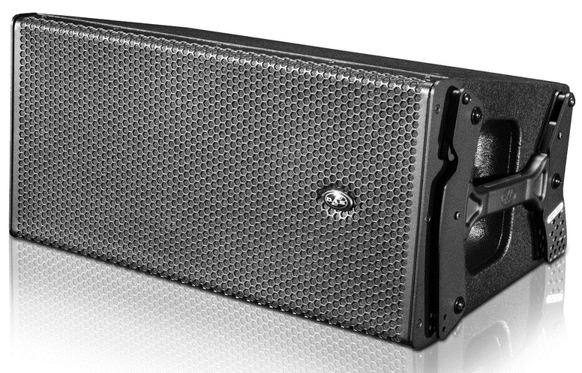  Gambar Alat : | 1 | Unit | …………. | ………..
  Nominal HF Amplifier Power | : | 100 W
  Nominal LF Amplifier Power | : | 500 W
  Frequency Range (-10 dB) | : | 63 Hz-20 kHz
  Rated Peak SPL at 1 m | : | 134 dB
  Horizontal Coverage (-6 dB) | : | 90º Nominal
  Vertical Coverage | : | Splay Dependent
  Enclosure Material | : | Birch Plywood
  Color/Finish | : | Black/ISO-flex Paint
  Connectors | : | Input: Female XLR
   |  | Loop Thru: Male XLR
   |  | AC Input: powerCON
   |  | AC Output: powerCON
  AC Requirements | : | 115 V, 50 Hz/60 Hz  230 V, 50 Hz/60 Hz
  Current Draw | : | (1/3 power @ 230 V) + 1.7A
  Dimensions (H x W x D) | : | 31.6 x 68.8 x 38.5 cm  12.4 x 27 x 15.2 in
  Weight | : | 27 kg (59.4 lb)
2 | RCF NX-10-SMA Stage Monitor | 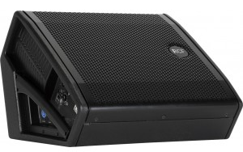  Gambar Alat : | 2 | Unit | ……….. | ………..
  Features:
  400 W digital bi-amplification
  Wide dispersion 60 x 60 constant directivity horn
  DSP processing, boost EQ, soft limiter and protection
  XLR jack input, XLR signal output
  Acoustical Specifications:
  Frequency Response -3 dB: 60 Hz 20 kHz
  Max SPL: 127 dB
  Horizontal coverage angle: 60
  Vertical coverage angle: 60
  Compression Driver: 1" neo compression driver, mylar dome
  Woofer: 10" neo high power woofer, 2.5" voice coil
  Input/Output Section:
  Input connectors: XLR jack
  Output connectors: XLR
  Processor Section:
  Limiter: Soft Limiter
  Controls: Freefield, floor
  Amplifier Specifications:
  Total power: 400 W
  High frequencies: 100 W
  Low frequencies: 300 W
  Cabinet:
  Cabinet Material: Baltic Birch
  Handles: 1 on side
  Pole Mount/Cap: Yes
  Grille: Steel
  Physical Specifications:
  Dimensions: 12.7" H x 17.7" W x 16.4 " D (324 x 450 x 417 mm)
  Net Weight: 31.96 lbs (14.5 kg)
3 | Michophone Shure Beta 58A | Gambar Alat : | 5 | Unit | ……….. | ………..
  Dynamic (moving coil)
  Frequency Response
  50 to 16,000 Hz
  NOTE: The curve above shows on-axis response at a distance of 2 feet from a uniform sound source. Your response may vary, depending on microphone position.
  Polar Pattern
  Supercardioid, rotationally symmetrical about microphone axis, uniform with frequency.
  Output Level (at 1,000 Hz)
  Open Circuit Voltage: -51.5 dBV/Pa* (2.6 mV)
  *1 Pa = 94 dB SPL
  Impedance
  Rated impedance is 150 ohms (290 ohms actual) for connection to microphone inputs rated low Z Phasing.
  Positive pressure on diaphragm produces positive voltage on pin 2 with respect to pin 3.
  Case
  Silver blue enamel-painted die cast metal with hardened, matte-finished, spherical steel mesh grille.
  Adjustable, Stand Adapter
  Slip-in microphone mounting, unbreakable, adjustable through 180 degrees with standard 5/8"-27 thread, black finish.
  Dimensions
  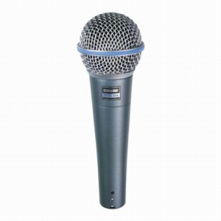
  See User Guide.
Total |  |  |  |  |  | ………….
Terbilang :
NB : Harga Sudah Termasuk Pajak

Pejabat Pembuat Komitmen,

Dr. H. Sugeng Listyo Prabowo, M.Pd
NIP. 19690526 200003 1 003

