
KEMENTERIAN AGAMA
UNIVERSITAS ISLAM NEGERI MAULANA MALIK IBRAHIM MALANG
Jl. Gajayana No. 50 Malang 65144, Telp. (0341) 551354, Fax. (0341) 572533
Website : www.uin-malang.ac.id
Nomor : Un.3/KS.01.7/4562/2016 28 November 2016
Lampiran : 1 (satu) bendel
Perihal : Permintaan Informasi Harga

Kepada Yth.
............................................................................................
di
‘- T e m p a t –

Dengan hormat,
Sehubungan rencana realisasi pelaksanaan pekerjaan Pengadaan Paket Sound System Ruang Meeting dan Outdoor UIN Maulana Malik Ibrahim Malang, bersama ini kami bermaksud agar perusahaan saudara memberikan informasi tentang Harga Jasa sesuai dengan Rincian Anggaran Biaya (RAB) yang kami lampirkan dalam surat ini.
Apabila informasi harga yang saudara berikan sesuai dan kami nilai wajar, maka kami akan memberi kesempatan perusahaan saudara untuk membuat penawaran terhadap pekerjaaan tersebut.
Kami harap data barang dapat kami terima paling lambat pada :
Hari : Rabu
Tanggal : 30 November 2016
Tempat : Kantor Unit Layanan Pengadaan
Lantai II Gedung Rektorat UIN Maulana Malik Ibrahim Malang
Jl. Gajayana No. 50 Malang (0341) 570886

Surat tentang informasi harga barang tersebut, ditujukan:
Kepada Yth:
Pejabat Pembuat Komitmen
Universitas Islam Negeri Maulana Malik Ibrahim Malang
Jalan Gajayana No. 50 Malang

Adapun informasi harga tersebut bisa dikirim via e-mail ke : ulp@uin-malang.ac.id atau ulp_uinmalang@kemenag.go.id atau bisa dikirim langsung ke kantor ULP atau di Fax ke (0341) 570886
Demikian atas perhatian dan kerjasamanya yang baik, kami sampaikan terima kasih.
Pejabat Pembuat Komitmen,

Dr. H. Sugeng Listyo Prabowo, M.Pd
NIP. 19690526 200003 1 003

Lampiran | : | Surat Permintaan Informasi Harga
Nomor | : | Un.3/KS.01.7/4562/2016
Tanggal | : | 28 November 2016

Rincian Anggaran Biaya (RAB)

Pekerjaan : Paket Sound System Ruang Meeting dan Outdoor
Lokasi : UIN Maulana Malik Ibrahim Malang
Tahun : 2016

No | Nama Barang | Spesifikasi Barang dan Gambar | Volume |  | Harga Satuan (Rp) | Jumlah (Rp)
A. | Paket Sound System Ruang Meeting Lt. 3 Gd. C, Berupa :
1 | Mackie SRM-450 V3 1000w | - Portable Loudspeaker  - FEATURES  1000W Class D and AB power amps with 12" high-output LF driver and 1.4" titanium dome compression driver  Precision 2-way crossover, driver alignment, and phase correction  Onboard eedback destroyer  2-channel mixer features XLR/TRS combination jacks and stereo RCA inputs  Smart Protect DSP component protection  Use for mains or stage monitoring  Lightweight  - SPECIFICATIONS  Gambar Alat : | 4 | Unit | …………. | ………..
  SRM450v3 1000W High-Definition Portable Powered Loudspeaker
  LF Driver Size: 12"
  HF Driver Size: 1.4"
  LF Driver Power Amp: 400W RMS, Class D
  HF Driver Power Amp: 100W RMS, Class AB
  Total Power: 500W (1000W peak)
  Frequency Range (-10dB): 42Hz-23kHz
  Crossover Frequency: 3kHz
  Maximum Peak SPL: 128dB SPL
  Horizontal Coverage Angle: 90 Degrees
  Vertical Coverage Angle: 45 Degrees
  Enclosure Material: Polypropylene
  Mounting Options: Floor, Pole, Fly
  Inputs: 2 x Combo (TRS/XLR), 1 x RCA
  Outputs: 1 x XLR (Thru)
  Height: 29"
  Width: 17.5"
  Depth: 17.0"
  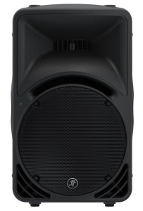
  Weight: 37 lbs.
2 | Mackie Pro FX22 V2 Series Analog Mixer | 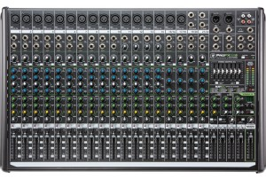  Gambar Alat : | 1 | Unit | ……….. | ………..
  Type | Analog
  Channels | 22
  Inputs - Mic Preamps | 16 x XLR
  Inputs - Line | 22 x TRS
  Inputs - Other | 1 x stereo RCA, 1 x 1/4" (Footswitch)
  Outputs - Main | 2 x XLR, 2 x TRS
  Outputs - Other | 2 x TRS (Control Room), 4 x (Sub), 1 x stereo RCA
  Headphones | 1 x 1/4"
  Send/Return I/O | 2 x 1/4" (Mon Send), 1 x 1/4" (FX Send), 2 x 1/4" (Aux Return)
  Phantom Power | 16 Channels
  EQ Bands | 3-band
  Busses/Groups | 4 x Bus
  Faders | 23 x 60mm Throw
  Channel Inserts | Yes
  Effects | Yes
  Computer Connectivity | 1 x USB
  Height | 3.8"
  Width | 25.1"
  Depth | 16.0"
  Weight | 18 lbs.
  Manufacturer Part Number | ProFX22v2
3 | Michophone Shure Beta 58A | Gambar Alat : | 2 | Unit | ……….. | ………..
  Dynamic (moving coil)
  Frequency Response
  50 to 16,000 Hz
  NOTE: The curve above shows on-axis response at a distance of 2 feet from a uniform sound source. Your response may vary, depending on microphone position.
  Polar Pattern
  Supercardioid, rotationally symmetrical about microphone axis, uniform with frequency.
  Output Level (at 1,000 Hz)
  Open Circuit Voltage: -51.5 dBV/Pa* (2.6 mV)
  *1 Pa = 94 dB SPL
  Impedance
  Rated impedance is 150 ohms (290 ohms actual) for connection to microphone inputs rated low Z Phasing.
  Positive pressure on diaphragm produces positive voltage on pin 2 with respect to pin 3.
  Case
  Silver blue enamel-painted die cast metal with hardened, matte-finished, spherical steel mesh grille.
  Adjustable, Stand Adapter
  Slip-in microphone mounting, unbreakable, adjustable through 180 degrees with standard 5/8"-27 thread, black finish.
  Dimensions
  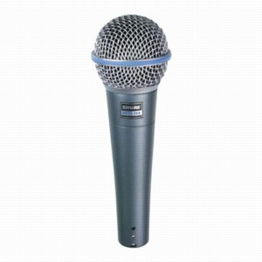
  See User Guide.
B. | Paket Sound System Outdoor, Berupa :
1 | Speaker DAS Aero 12 A | - Powered two-way, mid-high line array module  - Two channel amplifier 500 W LF + 100 W HF 3rd generation Class D  - One 12″ loudspeaker with neodymium magnetic assembly  - M-75N Neodymium compression driver with 1.5″ exit  - SERPIS high frequency plane wave generator  Captive rigging system integrated in the cabinet design  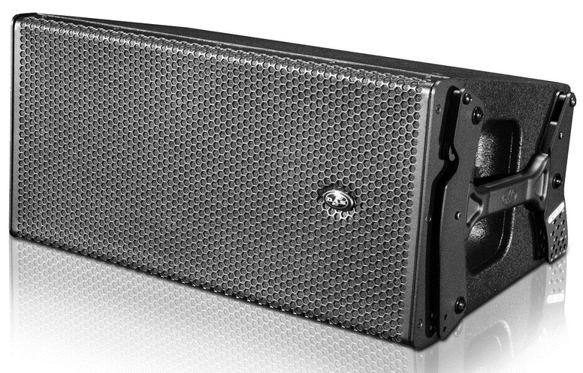  Gambar Alat : | 1 | Unit | …………. | ………..
  Nominal HF Amplifier Power | : | 100 W
  Nominal LF Amplifier Power | : | 500 W
  Frequency Range (-10 dB) | : | 63 Hz-20 kHz
  Rated Peak SPL at 1 m | : | 134 dB
  Horizontal Coverage (-6 dB) | : | 90º Nominal
  Vertical Coverage | : | Splay Dependent
  Enclosure Material | : | Birch Plywood
  Color/Finish | : | Black/ISO-flex Paint
  Connectors | : | Input: Female XLR
   |  | Loop Thru: Male XLR
   |  | AC Input: powerCON
   |  | AC Output: powerCON
  AC Requirements | : | 115 V, 50 Hz/60 Hz  230 V, 50 Hz/60 Hz
  Current Draw | : | (1/3 power @ 230 V) + 1.7A
  Dimensions (H x W x D) | : | 31.6 x 68.8 x 38.5 cm  12.4 x 27 x 15.2 in
  Weight | : | 27 kg (59.4 lb)
2 | RCF SUB 718-AS | Gambar Alat : | 2 | Unit | ……….. | ………..
  Spesifikasi RCF SUB 718-AS
  The SUB 718-AS is a compact and powerful subwoofer.
  Thanks to the powerful 18" woofer with 4" voice coil and a 700 W amplifier, the SUB 718-AS is the perfect tool to increase the low end performance of a portable PA system, both in terms of output and frequency extension.
  FEATURES
  1400 Watt Peak, 700 Watt RMS digital amplification
  132 dB max spl
  18" High power woofer, 4" voice coil
  Xover selector, phase switch and high pass outputs
  Electronic equalization, soft limiter and protection
  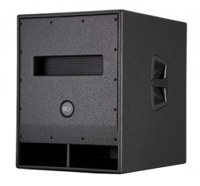
  Stereo Xlr/Jack combo input, Stereo Xlr signal output
3 | KLOTZ MC5000 STUDIO-MIC CABLE Studio |   Gambar Alat : | 2 | Unit | ……….. | ………..
  Microphone Cable, 0.50 mm conductor cross section, inner jac
  Construction:
  Conductor: stranded bare copper, 28 x 0.15 mm
  Cross Section: 0.50 mm²
  Insulation: PE
  Shielding: double, counter-rotating, bare copper spiral shield
  Outer Jacket: PVC / PUR
  Overall Diameter: 7.0 mm
  Mechanics:
  Min. Bending Radius:
  Working Temperature:
4 | Connector Neutrik Male Female | 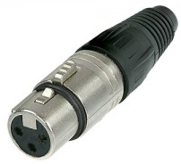  Gambar Alat : | 20 | Unit | ……….. | ………..
  Connector Neutrik Male Female
  Type : NC3FX dan NC3MX Original
Total |  |  |  |  |  | ………….
Terbilang :
NB : Harga Sudah Termasuk Pajak

Pejabat Pembuat Komitmen,

Dr. H. Sugeng Listyo Prabowo, M.Pd
NIP. 19690526 200003 1 003

