
KEMENTERIAN AGAMA
UNIVERSITAS ISLAM NEGERI MAULANA MALIK IBRAHIM MALANG
Jl. Gajayana No. 50 Malang 65144, Telp. (0341) 551354, Fax. (0341) 572533
Website : www.uin-malang.ac.id E-mail : info@uin-malang.ac.id
Nomor : Un.03/KS.01.7/1871/2017 19 Mei 2017
Lampiran : 1 (satu) bendel
Perihal : Permintaan Informasi Harga

Kepada Yth.
............................................................................................
di
‘- T e m p a t –

Dengan hormat,
Sehubungan dengan rencana realisasi pelaksanaan pekerjaan Pengadaan Belanja Modal Peralatan dan Mesin Berupa Barang Elektronik, bersama ini kami bermaksud agar perusahaan saudara memberikan informasi tentang Harga Jasa sesuai dengan Rincian Anggaran Biaya (RAB) yang kami lampirkan dalam surat ini.
Informasi harga yang saudara berikan, akan kami jadikan sebagai dasar pembuatan Harga Perkiraan Sendiri (HPS) lelang. Dan apabila informasi harga yang saudara berikan dibawah nilai lelang, maka kami akan melakukan klarifikasi lebih lanjut atas penawaran tersebut.
Kami harap data barang dapat kami terima paling lambat pada :
Hari : Selasa
Tanggal : 23 Mei 2017
Pukul : 11.00 WIB
Tempat : Kantor Unit Layanan Pengadaan
Lantai II Gedung Rektorat UIN Maulana Malik Ibrahim Malang
Jl. Gajayana No. 50 Malang (0341) 570886

Surat tentang informasi harga barang tersebut, ditujukan:
Kepada Yth:
Pejabat Pembuat Komitmen
Universitas Islam Negeri Maulana Malik Ibrahim Malang
Jalan Gajayana No. 50 Malang

Adapun informasi harga tersebut bisa dikirim via e-mail ke : ulpuinmaliki@gmail.com atau ulp_uinmalang@kemenag.go.id atau bisa dikirim langsung ke kantor ULP atau di Fax ke (0341) 570886/569901
Demikian atas perhatian dan kerjasamanya yang baik, kami sampaikan terima kasih.

Pejabat Pembuat Komitmen,

Dr. H. Sugeng Listyo Prabowo, M.Pd
NIP 19690526 200003 1 003

Lampiran :
Surat Permintaan Informasi Harga Barang
Nomor : Un.03/KS.01.7/1871/2017
Tanggal : 19 Mei 2017

Rincian Anggaran Biaya (RAB)

Pekerjaan : Pengadaan Belanja Modal Peralatan dan Mesin Berupa Barang Elektronik
Lokasi : Pusat Perpustakaan Universitas Islam Negeri Maulana Malik Ibrahim Malang
Tahun Anggaran : 2017

No | Nama Barang | Volume |  | Harga Satuan ( Rp ) | Jumlah Harga ( Rp )
1 | HP Desktop 550-125l [P4M27AA] (include Windows 8 Pro 64 bit) | 27 | unit
  Platform | Desktop PC
  Tipe Prosesor | Intel Core i5
  Processor Onboard | Intel® Core™ i5-6400 Processor (2.7 GHz, 6M Cache) up to 3.30 GHz
  Chipset | Intel H87
  Memori Standar | 4GB DDR3
  Tipe Grafis | AMD Radeon R5 330 2GB DDR3
  Audio | Integrated
  Hard Drive | 1TB
  Optical Drive | DVD±RW
  Networking | Integrated
  Kecepatan Jaringan | 10/100/1000
  Keyboard | Wireless Keyboard
  Ragam Input Device | Wireless Mouse
  Ragam Card Reader | 7-in-1 Media Card Reader
  Antarmuka / Interface | - 4x USB 3.0  - 2x USB 2.0  - 1x headphone/microphone combo
  Sistem Operasi | Windows 8 pro 64bit
  Monitor | 21.5 Inch
  Chassis Form Factor | Mini Tower ATX
2 | Laptop | 2 | unit
  Platform | Notebook
  Tipe Prosesor | Intel Core i7
  Processor Onboard | Intel® Core™ i7-6500U Processor (2.5GHz, 4M Cache) up to 3.10 GHz
  Memori Standar | 4GB DDR3L
  Tipe Grafis | Nvidia GeForce 940M 2GB
  Ukuran Layar | 14 Inch
  Resolusi Layar | 1366 x 768
  Tipe Layar | LED Backlit
  Audio | Integrated
  Speaker | Integrated
  Kapasitas Penyimpanan | 1TB HDD
  Optical Drive Type | DVDRW
  Networking | Integrated
  Kecepatan Jaringan | 10/100 Mbps
  Wireless Network Type | Integrated
  Wireless Network Protocol | IEEE 802.11b, IEEE 802.11g, IEEE 802.11n
  Wireless Bluetooth | Integrated  Bluetooth® 4.0 combo
  Keyboard | Island-style keyboard
  Ragam Input Device | Touchpad with multi-touch gesture support
  Card Reader Provided | 1 multi-format SD media card reader
  Antarmuka / Interface | - 2 USB 3.0  - 1 USB 2.0  - 1 HDMI  - 1 RJ-45  1 headphone/microphone combo
  Sistem Operasi | Microsoft Windows 8
  Baterai | 4 Cell
  Daya / Power | External AC Adapter  65 W AC power adapter
  Dimensi (PTL) | 34.54 x 24.25 x 2.5 cm
  Berat | Starting at 1.96 kg
3 | HONEYWELL Scanner Orbit [MK7120-31A38] – Black  Technical Information  - Barcode Dimension: 1D  - Scan Pattern: Single Line/ Omni-directional  - Connectivity Technology: Cable  - Light Source: Laser  - Barcode Symbology Supported: Reads standard 1D and GS1 DataBar symbologies  - Maximum Scan Resolution: 5 mil  General Information  - Product Type: Desktop Barcode Scanner  - Brand Name: Honeywell  - Manufacturer: Honeywell International, Inc  - Product Model: MS7120-38-3  - Product Name: Orbit 7120 Omnidirectional Laser Scanner  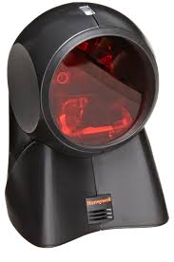  - Product Line: Orbit  Physical Characteristics  - Height: 5.9"  - Width: 4"  - Color: Black  - Length: 4.1"  - Weight (Approximate): 14.10 oz  Other  - Certifications & Standards:  - Laser Class 1:  - EN: 60825-1:1994+A11:1996+A2:2001  - EMC:  - Class B: FCC Part 15  - ICES-003  - EN 55022 Class B  Additional Information: Supported Interface: USB | 5 | unit
4 | ACCESS POINT (outdoor)  Ubiquiti UAP-AC-OUTDOOR UniFi Access Point Networks  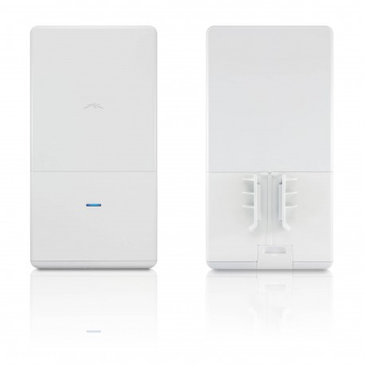 | 4 | unit
  Networking Interface | 2 x 10/100/1000 Ethernet ports
  Button | Reset
  Antennas | 2.4 GHz: Integrated 5 dBi omni (supports 3x3 MIMO with spatial diversity)  5 GHz: Integrated 5 dBi omni (supports 3x3 MIMO with spatial diversity)
  Wi-Fi Standards | 802.11a/b/g/n/ac
  Power Method | Passive Power over Ethernet (48 V), 802.3at Supported  (Supported Voltage Range: 39 to 57 VDC)
  Power Supply | 48 V, 0.5 A PoE Gigabit adapter (included)
  Maximum Power Consumption | 22 W
  Maximum TX Power | 2.4 GHz: 28 dBm  5 GHz: 28 dBm
  BSSID | Up to 4 per radio
  Power Save | Supported
  Wireless Security | WEP, WPA-PSK, WPA-Enterprise (WPA/WPA2, TKIP/AES)
  Certifications | CE, FCC, IC
  Mounting | Wall/Ceiling
  VLAN | 802.1Q
  Advanced QoS | Per user rate limiting
  Guest Traffic Isolation | Supported
  WMM (Wi-Fi Multimedia) | Voice, video, best effort, and background
  Concurrent Clients | 200+
5 | Printer InkJet EPSON Printer [L120] | 4 | unit
  Metode Cetak | 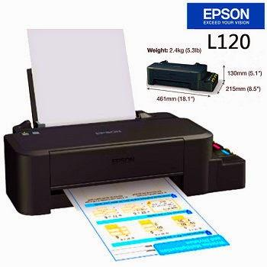  InkJet
  Maks. Besaran Kertas | A4
  Maks. Resolusi | 720
  Effective Print Resolution | 720 x 720 dpi
  Kecepatan Cetak B/W | - 8.5 ipm
  Kecepatan Cetak Warna | 4.5 ipm ppm
  Konektivitas | USB
  Kesesuaian Sistem Operasi | - Windows XP/XP Professional x64 Edition/Vista/7/8/8.1  - Mac OS X 10.5.8, 10.6.x, 10.7.x, 10.8.x, 10.9.x
  Input Tray #1 | 50 sheets, A4 Plain paper (75g/m²)
  Duplex Printing | Manual
  Power Consumption | - Printing : Approx. 10W  - Standby : Approx. 2.0W  - Sleep : Approx. 0.6W  - Power Off : Approx. 0.3W
  Dimensi | 461 x 215 x 130 mm (W x D x H)  Dimensi Kemasan : 55 x 30 x 19 cm
  Consumables | - Black Ink Catridge [T6641]  - Cyan Ink Catridge [T6642]  - Magenta Ink Catridge [T6643]  - Yellow Ink Catridge [T6644]
6 | 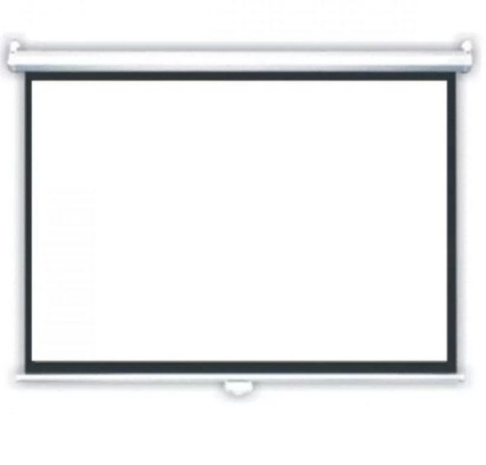  LAYAR PROYEKTOR  World Screen Motorized 150" | 1 | unit
  Berat | - 18 Kg  - Motorized Screen 305cm x 228cm
7 | SWITCH HUB  TP-LINK TL-SG1024 Gigabit Rackmount Switch | 2 | unit
  Standards and Protocols | IEEE 802.3i, IEEE 802.3u, IEEE 802.3ab , IEEE 802.3x
  Interface | 24 10/100/1000Mbps RJ45 Ports (Auto Negotiation/Auto MDI/MDIX)
  Network Media | 10BASE-T: UTP category 3, 4, 5 cable (maximum 100m)  100BASE-TX/1000BASE-T: UTP category 5, 5e or above cable (maximum 100m)
  Fan Quantity | Fanless
  Power Supply | 100-240VAC, 50/60Hz
  Power Consumption | Maximum: 13.1W (220V/50Hz)
  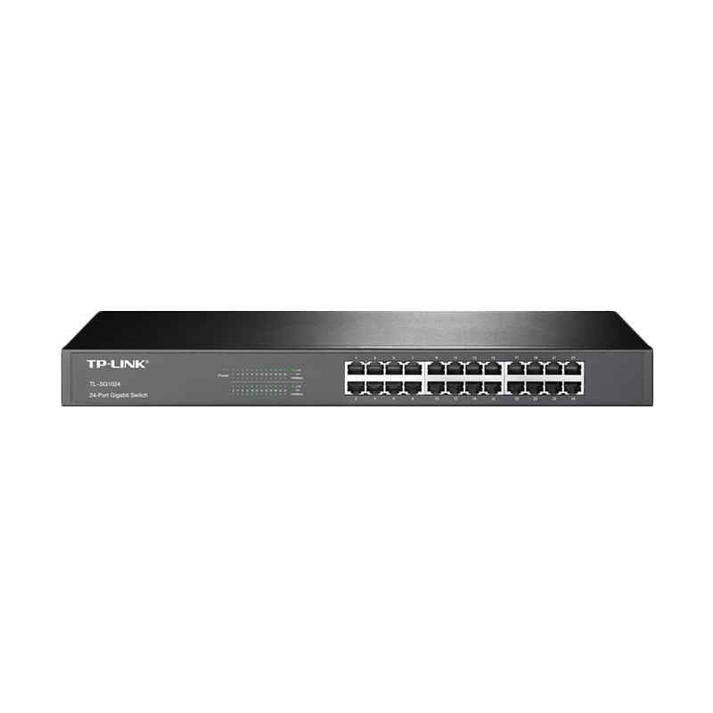  Dimensions ( W x D x H) | 17.3*7.1*1.7 in. (440*180*44 mm)
  PERFORMANCE
  Switching Capacity | 48Gbps
  Packet Forwarding Rate | 35.7Mpps
  MAC Address Table | 8K
  Jumbo Frame | 10KB
  QoS | 802.1p/DSCP QoS*  *Only for V11 and later version
8 | 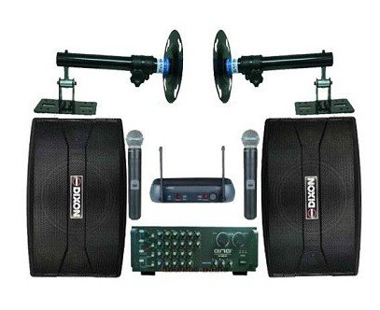  MEETING ROOM AUDIO  TECHNIC AUDIO Sound System  List Item :  - 1 unit amplifier BMB DA-1600SE  - 2 unit speaker pasif Dixon FA-100 (10inch)  - 1 unit microphone wireless shure SLX-242 (2Mic)  - 2 unit bracket speaker/stand speaker (pilih)  - 2 roll kabel speaker 2x100 30 | 1 | unit
9 | Resensitizer  3M Model 764 Resensitizer  - An electrical, portable unit to fully resensitize 3M™ Security Strips on print and CD materials, ensuring a fully secured collection  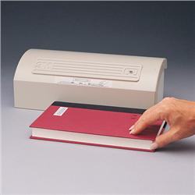  - Green light signals that the unit is operating  - UL-Certified  Component Style: Desktop  Compliant: UL-Certified  Dimension: 4"H x 12-1/4"W x 5-1/2"D | 1 | unit
10 | 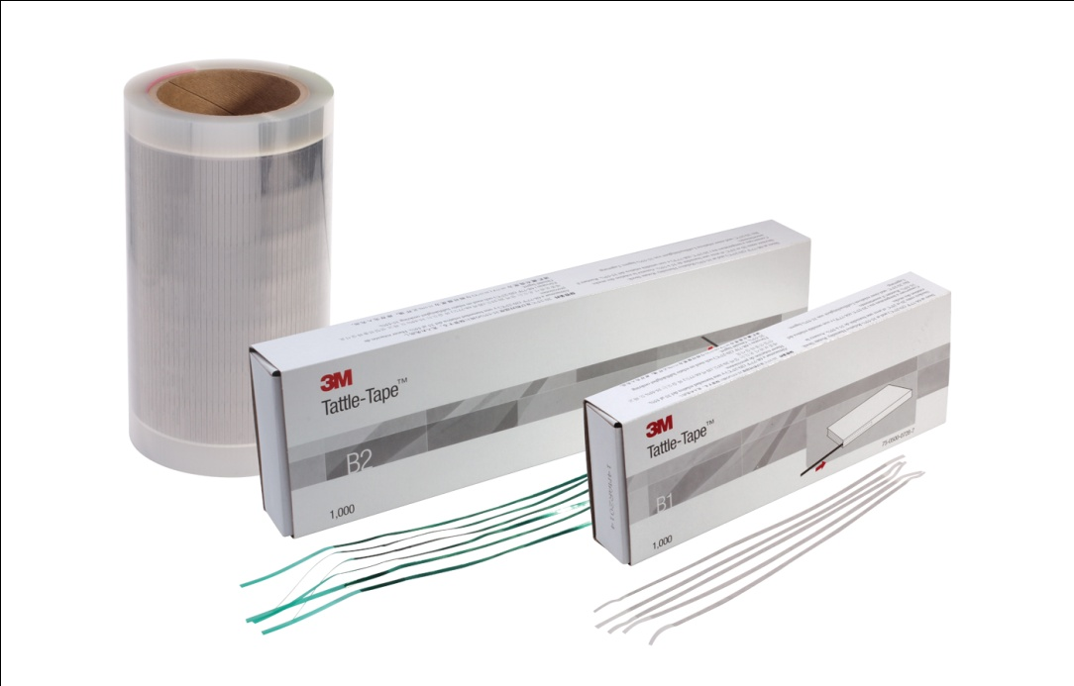  TATTLE TAPE  3M B2 TATTLE TAPE  Dimensi max. : 165 mm x 3 mm x 0,5 mm  Catu daya : 0 ( tidak mengkonsumsi energi listrik )  Dapat diaktifkan/non-aktifkan oleh 3M sensitizer/desensitiser  Jumlah per-box: 1000 buah | 1 | unit
11 | 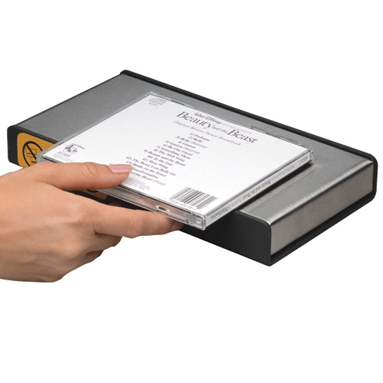  Desensitizer  3M Model 930 Desensitizer  Component Style: Desktop  Compliant: UL-Certified  Dimension: 1-1/2"H x 10"W x 5"D | 4 | Box
12 | 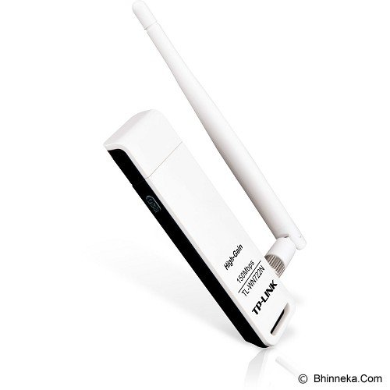  USB Wireless Adapter  TP-LINK TL-WN722N | 10 | unit
  Encryption | - 64/128 bits WEP  - WPA/WPA2, WPA-PSK/WPA2-PSK (TKIP/AES)
  Operating Frequency | 2.4-2.4835GHz
  Modulation | OFDM/CCK/16-QAM/64-QAM
  Output Power | 20dBm
  Dimensions | 3.7 x 1.0 x 0.4in. (93.5 x 26 x 11mm)
  Standards Protocol | IEEE 802.11n,IEEE 802.11g, IEEE 802.11b
13 | Braket TV Standing  Braket TV Standing/Breket Standing Floor TV LED (32"-70")  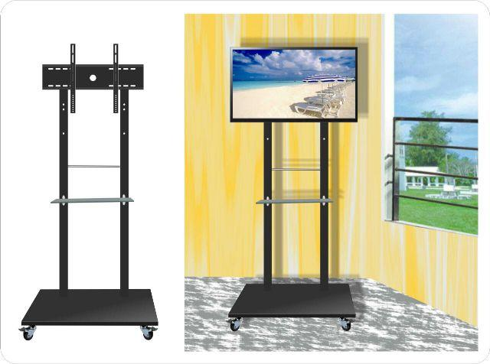  - cang untuk : LCD/LED TV ukuran 40 " - 60 "  - Kapasitas Berat : 45.5kg  - TV penyesuaian Tinggi : 1030mm ( 40,5 ) ~ 1530mm ( 60,2 ) .  - Warna finishing : Cat hitam  - VESA Standar mulai : 200x200,200x400,400x400,400x600,400x700,500x800  - Manajemen kabel Terpadu dalam tiang | 3 | unit
NB :
* Mohon dicantumkan spesifikasi lengkap dan merek barang

Pejabat Pembuat Komitmen,

Dr. H. Sugeng Listyo Prabowo, M.Pd
NIP 19690526 200003 1 003

