
KEMENTERIAN AGAMA
UNIVERSITAS ISLAM NEGERI MAULANA MALIK IBRAHIM MALANG
Jl. Gajayana No. 50 Malang 65144, Telp. (0341) 551354, Fax. (0341) 572533
Website : www.uin-malang.ac.id E-mail : info@uin-malang.ac.id

Nomor : Un.03/KS.01.7/2703/2017 27 Juli 2017
Lampiran : 1 (satu) bendel
Perihal : Permintaan Informasi Harga

Kepada Yth.
............................................................................................
di
‘- T e m p a t –

Dengan hormat,.
Sehubungan rencana realisasi pelaksanaan pekerjaan Pengadaan Belanja Modal Peralatan dan Mesin Prodi Pendidikan Dokter UIN Maulana Malik Ibrahim Malang Tahun Anggaran 2017, bersama ini kami bermaksud agar perusahaan saudara memberikan informasi tentang harga barang sesuai dengan Rencana Anggaran Biaya (RAB) yang kami lampirkan dalam surat ini.
Apabila informasi harga yang saudara berikan sesuai dan kami nilai wajar, maka kami akan memberi kesempatan perusahaan saudara untuk membuat penawaran terhadap pekerjaaan tersebut.
Kami harap data barang dapat kami terima paling lambat pada :
Hari : Rabu
Tanggal : 02 Agustus 2017
Pukul : 09.00 WIB
Tempat : Kantor Unit Layanan Pengadaan
Lantai II Gedung Rektorat UIN Maulana Malik Ibrahim Malang
Jl. Gajayana No. 50 Malang (0341) 570886

Surat tentang informasi harga barang tersebut, ditujukan:
Kepada Yth:
Pejabat Pembuat Komitmen FKIK
Universitas Islam Negeri Maulana Malik Ibrahim Malang
Jalan Gajayana No. 50 Malang

Adapun informasi harga tersebut bisa dikirim via e-mail ke : ulp@uin-malang.ac.id atau ulp_uinmalang@kemenag.go.id atau bisa dikirim langsung ke kantor ULP atau di Fax ke (0341) 570886
Demikian atas perhatian dan kerjasamanya yang baik, kami sampaikan terima kasih.
Pejabat Pembuat Komitmen,

Ach. Nashichuddin, MA
NIP 19730705 200003 1 002

Lampiran :
Surat Permintaan Informasi Harga Barang
Nomor : Un.03/KS.01.7/2703/2017
Tanggal : 27 Juli 2017

Rincian Anggaran Biaya (RAB)

Pekerjaan : Belanja Modal Peralatan dan Mesin Prodi Pendidikan Dokter
Lokasi : Fakultas Kedokteran Dan Ilmu-Ilmu Kesehatan
Tahun Anggaran : 2017

No | Nama Barang | Spesifikasi | Volume |  |  | Harga (Rp) | Jumlah (Rp)
Sarana Prasarana Laboratorium Anatomi
1. | Meja kadaver | This embalming table is constructed of a stainless steel top with a convex surface, stainless steel frame and 6” ball-bearing wheel. The swivel wheels lock to keep the table stationary while in use. The drain, located in the center of the foot end, quickly eliminates fluid from the table. It can stand on one end for storage behind a door or in a closet when not in use.  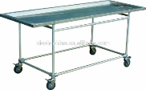 | 2 | unit
2. | Minor set | Tiap Set terdiri dari :  - Thumb Dressing Forcep 14 cm : 1pcs  - Tissue Forcep (12 Teeth) : 1 pcs  - Standard Operating Scissor STR-Sh/BI 14 cm : 1 pcs  - Knapp Vascular Scissor One Blade Pointed 11,5 cm : 1 pcs  - Rochester Pean Haemostatic Forcep STR 14 cm : 2 pcs  - Halsted Mosquito Haemostatic Forcep CVD 12,5 cm : 2 pcs  - Mayo Hegar Handle Holder 14 cm : 1 pcs  - Scalpel Handle No. 3 : 1 pcs  - Mini-Langenbeck Retractor : 1 pcs  - Needle Case (50x30x6 mm) : 1 pcs  - Case for Scalpel Blades : 1 pcs  - Case Instruments : 1 pcs  - Box Packing : 1 pcs  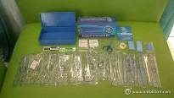 | 5 | set
 | Rak Besi PxT (100-200 cm) | Spesifikasi Ukuran:  P x L x T ( 100Cm x 40 Cm x 200Cm )  Sistem baut / Knock Down  Tebal ambalan 0,75 mm  Tebal tiang / besi siku 2 mm  Kapasitas 100 kg  Termasuk karet kaki  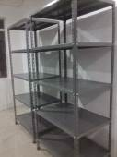 | 6 | unit
3. | Penyangga buku dengan tripod | Spesifikasi :  Mekanisme tiga bagian memungkinkan untuk posisi yang lebih rendah  Berlubang Meja Folding dengan halaman pengikut  Frictioning EZ Angle Roller  Quik-N-EZ Retainer  Quik-N-EZ Penyesuaian Tinggi Grip  Tripod Basis terbuat dari tahan lama aluminium die cast  Ukuran meja: 480 mm x 345 mm (18,9 "x 13,6")  Tinggi: 610 mm - 1.150 mm (24 "- 45.3")  Berat: 3.15 kg (6,9 lbs.)  radius dasar: 345 mm (13,6 ")  Kapasitas beban: 5 kg (11 lbs.)  Ukuran dilipat: 680 mm x 130 mm x 215 mm (26,7 "x 5,1" x 8,5 ")  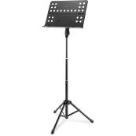 | 5 | unit
4. | Sentrifuge | Brand : Thermo Scientific, Designed in Germany  Manufacture in China (Under Thermo Scientific ISO and Requirements)  Model : SL8, Ventilated, 230 V, 50/60 Hz; 75007221  Swing Bucket Rotors  Max Capacity 4 x 145 mL (with TX-150 rotor)  Max Speed 4,500 rpm (with TX-150 rotor)  Min Speed 300 rpm (with TX-150 rotor)  Max RCF 3,260 x g (with TX-150 rotor)  Fixed Angle Rotors  Max Capacity 6 x 50 mL (with HIGHConic rotor)  Max Speed 16,000 rpm (with MicroClick 24 rotor)  Min Speed 300 rpm (with MicroClick 24 rotor)  Max RCF 24,328 x g (with MicroClick 24 rotor)  Control System : Microprocessor  Drive System : Direct, brushless induction drive  Rotor Locking System : Auto-Lock rotor exchange  Imbalance Detection System : Continuous vibration measurement, with rotor mass correction  Programs 4 direct program buttons, with alphanumeric program naming  Pulse (Short) Run : Yes  Acceleration/ Deceleration Rates 2 : (standard and soft)  Centrifugation Chamber : Brushed stainless steel  Max Timer Range : 99h 59min, continuous  Sound Level : <58 dBA (with TX-150 rotor); <61 dBA (with MicroClick 24 rotor)  Other Features : Certified1 ClickSeal biocontainment lids  Multilingual selection: English, Dutch, French, German, Italian, Russian and Spanish  Max Power Consumption : 310 W  Dimensions WDH (Lid closed) : 37 x 48 x 31 cm; H (Lid Open) : 67 cm  Weight : 35 kg  Standards & Certifications  Standards : IEC 61010-1, IEC 61010-2-020, IEC 61010-2-101, EN 61326-1  Certifications : UL Listed / CE marked / IVD compliant / Certified biocontainment  Include :  High Capacity Cell Culture Rotor Package, including :  Swinging Bucket Rotor, 90°, Rmax 144 mm  50ml conical buckets; Capacity : 8 x 50 ml  Adapters for 15ml conical tubes (4pk); Capacity : 8 x 15 ml  Round Buckets (set of 4)  ClickSeal Biocontainment Lids for Round Buckets (set of 4)  Adapters for 10 mL Blood Collection Tube (set of 4); Capacity : 16 x 10 ml  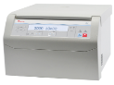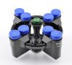 | 1 | Paket
5. | Vortex | Brand : IKA, Germany  Manufacture for Asia Pasific in Malaysia (under IKA Germany Licence)  Model : VORTEX 3; # 3340000  Type of movement : orbital  Shaker diameter : 4 mm  Motor rating input : 58 W  Motor rating output : 10 W  Permissible ON time : 100 %  Speed min (adjustable) : 500 rpm  Speed range : 0 - 2500 rpm  Speed display : none  Timer : no  Operating mode : continuous operation  Touch function : yes  Shaking table lock : no  Working with microtiter plates : yes  Number of microtiter plates : 1  Dimensions (W x H x D) : 127 x 136 x 149 mm  Weight : 4.5 kg  Permissible ambient temperature : 5 - 40 °C  Permissible relative humidity : 80 %  Protection class according to DIN EN 60529 : IP 21  RS 232 interface : no  Analog output : no  Voltage : 200 - 240 / 115 / 100 V  Frequency : 50/60 Hz  Power input : 60 W  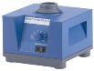 | 1 | Paket
Sarana Prasarana Laboratorium Histologi-Patologi Anatomi
6. | Kursi Dingklik | Kursi dingklik  - Bahan Kayu Jati,  - Finishing: Natural  - Standard Konstruksi Jepara  - Ukuran sbb: Diameter 30cm, Tinggi 45  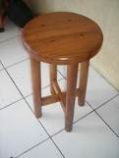 | 50 | buah
Sarana Prasarana Laboratorium Fisiologi-Farmakologi
7. | Laboratory Oven | Brand : Memmert, Germany  Model : UN110  Temperature  Set temperature range in °C : min. 5°C above ambient up to +300°C  resolution of display for setpoint values 0.1°C up to 99.9°C, 0.5°C from 100°C and for actual values 0.1°C (LED)  Control of standard components  Temperature : 1 Pt100 sensor DIN class A in 4-wire-circuit  ControlCOCKPIT : adaptive multifunctional digital PID-microprocessor controller with high-definition TFT-colour display  Control technology  Timer : Digital backwards counter with target time setting, adjustable from 1 minute to 99 days  Function SetpointWAIT : the process time does not start until the set temperature is reached  Calibration : three freely selectable temperature values  Language setting : German/English/Spanish/French  adjustable parameters : temperature (Celsius or Fahrenheit), air flap position, programme time, time zones, summertime/wintertime  Ventilation  natural convection  Fresh air admixture : adjustment of pre-heated fresh air admixture by air flap control in 10 % steps  Vent : vent connection with restrictor flap  Communication  Documentation : programme stored in case of power failure  Programming : AtmoCONTROL software for reading out, managing and organising the data logger via Ethernet interface (temporary trial version can be downloaded). USB stick with AtmoCONTROL software available as accessory (on demand).  Safety  Temperature control : adjustable electronic overtemperature monitor and mechanical temperature limiter TB, protection class 1 according to DIN 12880 to switch off the heating approx. 20°C above nominal temperature  Autodiagnostic system : for fault analysis  Standard equipment  Scope of delivery : incl. works calibration certificate for +160°C  Door : fully insulated stainless steel door with 2-point locking (compression door lock)  Interior : easy-to-clean interior,made of stainless steel,reinforced by deep drawn ribbing with integrated and protected large-area heating on four sides  Internals : 2 stainless steel grids  Stainless steel interior  Max. loading of chamber: 175 kg  Dimensions WHD in mm : w(A) x h(B) x d(C): 560 x 480 x 400 mm  Volume : 108 L  Textured stainless steel casing  Housing : rear zinc-plated steel  Dimensions : w(D) x h(E) x d(F): 745 x 864 x 584 mm  Electrical data  Voltage Electrical load : 230 V, 50/60 Hz  approx. 2800 W  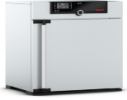 | 1 | unit
8. | Vortex mixer | Type of movement : orbital  Shaker diameter : 4.5 mm  Permissible shaking weight (incl. attachment) : 0.5 kg  Motor rating input : 10 W  Motor rating output: 8 W  Permissible ON time: 100 %  Speed min (adjustable): 200 rpm  Speed range : 0 - 3000 rpm  Speed display : scale  Timer : yes  Timer display : 7 segment LED  Time setting range : 1/60 - 999 min  Operating mode : timer and continuous operation  Touch function : yes  Shaking table lock : no  Working with microtiter plates : yes  Dimensions WHD : 148 x 63 x 205 mm  Weight : 2.9 kg  Permissible ambient temperature : 5 - 40 °C  Permissible relative moisture : 80 %  Protection class according to DIN EN 60529: IP 21  Voltage : 100 - 240 V; Frequency : 50/60 Hz  Power input : 20 W; DC Voltage : 24 V=  Current consumption : 800 mA  Include :  Microtiter attachment  Standard attachment  Universal attachment  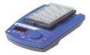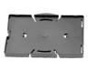  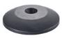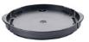 | 2 | unit
Sarana Prasarana Laboratorium Mikrobiologi-Parasitologi
9. | Laboratory timer | Fisher Scientific™ Traceable™ Multi-Colored Timer  Assorted bold colors for distinctive appearance. Fisher Scientific™ Traceable™ Multi-Colored Timer is supplied with 3 unique colorful frames, permitting personalization.  Four separate timing channels, plus recall memory  Times up to 99 hours, 59 minutes, 59 seconds  Resolution: 1 second  Accuracy is 0.01%  Count-up/count-down/alarm/clock  Easel bench stand and magnetic back  Unique memory returns channel to previously programmed setting at the touch of a key  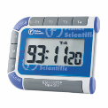 | 5 | unit
10. | Incubator shaker | Incu-Shaker™ Mini with non-slip rubber mat, 230V  H1000-M-E Benchmark Scientific  Temp. Range (H): Ambient +1°C to 60°C  Speed: Variable, 30 to 300 rpm  Orbit: 19mm/ 3-4 in.  Temp. Range: Ambient +5 to70°C  Temp. Increment: 0.1°C  Temp. Accuracy: ± 0.1°C  Temp. Uniformity: ± 0.25°C  Speed Increment: 1 rpm  Platform Dimensions: 9.5 x 11.5 in/23.5 x 29 cm  Operating Temp. Range : +4 to + 65°C  Universal Spring Platform for Unique Vessel  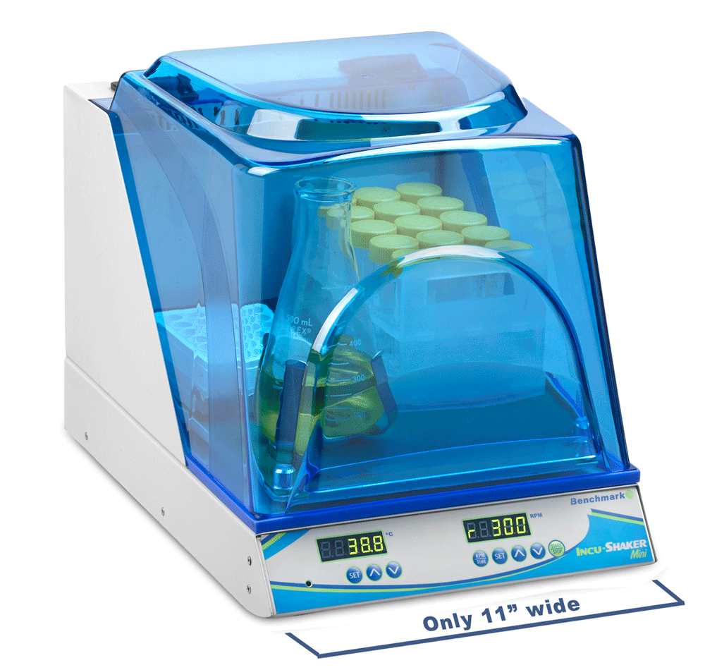 | 1 | unit
11. | Automatic colony counter | Program specifications :  Counts up to 7 different colors on the same plate  Automatically adapts to all kind of agar (chromogenic…)  Read Spiral®, spread and pour plates and inhibition zones  6 combinations of lighting and background color:  - lighting (upper and/or lower)  - sliding background (white or black)  User friendly software : press one button to count  One cursor to optimize counting  One window access to all functions  Polygonal exclusion areas  Minimum size of detected colony : < 0.1 mm  Automatic separation of clustered colonies  Clear and precise vizualisation of detected colonies: their center is marked with the cross  Zoom on the image function : X7  All recorded data is saved and automatically transferrable to :  Excel, PDF, JPG, BMP.  Connectable to LIMS  IQ, OQ, PQ, in compliance CFR21 part 11  ISO 9001-2000, CE  Technical specifications :  Lighting with long-life LEDs, Darkfield technology  Firewire CMOS color camera (640 x 480 pixels)  Software compatible Windows 8, 7, Vista  Multi-lingual software : English, French, Russian,  Japanese, Chinese, Spanish  Possibility of LIMS and barcode connection  Stainless steel, compact (24 cm width)  Dimensions of unit : 25 x 24 x 25 cm, 6.6 Kg  Dimensions of box : 40 x 40 x 50, 10 Kg  Delivered with one unit :  Firewire PCI card, PCI express card adapter  Expresscard, 6/4 pins adapters  CD Rom Software  Connecting cables  User's manual  2 validation plates  Include :  USB connector  CD Rom Software  Connecting cables  User's manual  3 validation plates  Adapter for 55 mm plates; to center 55 mm plates under the camera  Personal Computer  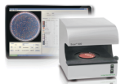 | 1 | unit
Sarana Prasarana Laboratorium Biokimia-Patologi klinik
12. | Ph meter elektrik | Digital PH Meter  Brand : Lovibond Tintometer, Germany  Model : SensoDirect pH110; 721300  Display : LCD, 21.5 mm (0.7“) digit height  Measurement Range : 0 - 14 pH  Resolution : 0.01 pH  Accuracy : ± 0.07 pH (pH 5 - pH 9)  ± 0.1 pH (pH 4 - pH 10)  ± 0.2 pH (pH 1 - pH 3.9, pH 10.1 - pH 13)  Main instrument only 23 ± 5°C, after calibration  Input Impedance : 1012 Ohms  Temperature Compensation : No adjustment  Sample Time : Approx. 0.4 seconds  Operating Temperature : 0 - 50°C (32 - 122°F)  Operating Humidity : Maximum 80% relative humidity  Calibration : External, pH 4.0 (slope adjustment) & pH 7.0 (Cal. adjustment)  Power Supply : 006P DC 9V battery  Power Consumption : Approx. 2.0 mA  Dimension : 208 x 110 x 34 mm (L x W x H)  Weight : Approx. 380 g  pH electrode : pH plastic type, gel electrolyte with BNC Connector  include : pH-buffer (4.0 / 7.0)  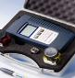 | 1 | unit
13. | Blood analyzer | Automated Hematology Analyzer XP-Series XP-100  Analysis Principle WBC : DC detection method  RBC/PLT: DC detection method  HGB: Non-cyanide haemoglobin analysis method  Parameters Whole blood mode, pre-diluted mode  WBC, RBC, HGB, HCI MCY MCH, MCHC,PLT  LYM%, MXD%, NEUT%, LYM#, MXD#, NEUT*  RDW-SD, RDW-CV, PDW*, MPV PCI P-LCR*  Throughput Approx. 60 samples per hour  SampleVolume WB mode Approx.50pL  PD mode Approx.2opt  Sample lD. Up to 15 characters  Quality Control Eightcheck-3wP (Low, Normal, High)  Material  Quality Control 60 plots r 6 fila.  CalibratorMate.ial scs-]o00  Dimension Main unit:420 x 355 x 480 mm  (WxDxH)  Weight Approx.3o kg  Data Storage XP-IOo  Up to 35,000  with histogram  Printer Built-in Thermal Printer  lnterfaces LAN (Ethernet for host computer)  Bar code reader (Handheld)  Serial port (for host computer/RS 232 C)  Graphic Printer (option)  LAN (SNCS service)**  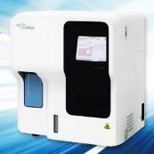 | 1 | unit
Sarana Prasarana Laboratorium Biologi Sel dan molekuler
14. | Perangkat elektroforesis horizontal | Horizontal Electrophoresis  Mini-Sub® Cell GT Horizontal Electrophoresis System and PowerPac™ Basic Power Supply  Includes :  Sub Cell unit Casting gates two 1.5 mm fixed-height combs (8- & 15-well), UV-transparent gel tray (7 x 10 cm), mini gel caster and PowerPac Basic power supply  Specifications :  Gel Size (width x Length) : 7 x 10 cm  Sample Throughput : 8 - 30  Base Buffer Volume : 0.27 L  Cell Size (L x W x H) : 26 x 12 x 6.5 cm  Distance to Electrode : 14.5 cm  Bromphenol Blue (Dye) : 4.5 cm/hour  Migration Rates : @ 75 V  PowerPac Basic Power Supply  Output range : 10 - 300 V in 1 V steps  (Programmable) 4 - 400 mA in 1 mA steps 75 W maximum  Type of output : Constant voltage or constant current with automatic crossover  Output terminals : 4 recessed sets in parallel  Timer : 1 - 999 minutes  Regulatory certification : IEC 1010-1,CE  Safety features : No-load detection  sudden load change detection  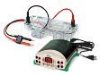 | 1 | unit
15. | Aqua destilator | Brand : Evoqua, Germany  Model : Labostar PRO TWF UV; W3T324338  Produce ultrapure water straight from your drinking water supply  The water quality exceeds all relevant standards including ASTM Type I, CLSI and ISO 3696 Type I  A conductivity sensor constantly measures the product water purity in the recirculation loop  A positively charged 0.2 μm sterile filter at the dispenser removes bacteria and endotoxins, eliminating the need for an expensive ultra-filter  Type III water specifications :  Flow rate @ 25°C : 9 l/h  Flow rate @ 20°C : 8 l/h  Flow rate @ 15°C : 7 l/h  Rejection rate for ions : 98 max %  Rejection rate for bacteria : >99 %  Rejection rate for particles : >99 %  Type I water specifications :  Output up to : 1,2 l/min  Conductivity @ 25°C : 0,055 μS/cm  Resistivity @ 25°C : 18,2 MΩ-cm  TOC : 1-5 ppb  Bacteria : <1 cfu/ml  Endotoxins : <0,001 EU/ml  Particles > 0.2 μm : <1 per ml  Feed water specifications :  Pressure : 3-5 bar  Conductivity : <1400 μS/cm  Colloid Index : <3 SDI  Free Chlorine : <0,5 mg/l  Fe : <0,1 mg/l  CO2 max. : 15 mg/l  Water temperature : 5-30°C  Ambient temperature : 5-35°C  Connections  Raw water : 5/16” push-in / flex tube R =  Pure water : ¼” push-in / flex tube d =  Drain concentrate : 3/8” push-in / flex tube d =  Power requirements  Power consumption : 270 W  Power supply : 100-240V/ 50-60Hz  Dimensions  Height : 535 mm  Width : 400 mm  Depth : 520 mm  Include :  Pretreatment  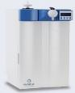 | 1 | unit
Sarana Prasarana Laboratorium Kedokteran dan Komunitas
16. | Refrigerator 2 pintu | Lemari Es 2 Pintu dengan kapasitas 225 L  LED Lighting, Moist Balance Crisper & Multi Air Flow  Big Size Veggie Box Tempered Glass  225 L  Deskripsi Produk :  LED Lighting  Pull-out Tray  Moist Balance Crisper and Multi Air Flow  "Big Size Veggie Box :  Extended Veggie Box provides 28L of storage space. "  Dimension 555 x 1520 x 585mm  Ada di Dalam Kotak : Lemari Es LG GN-B252SLCL, 1 Kartu Garansi dan 1 Buku Petunjuk  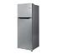 | 2 | unit
NL | Sarana Prasarana Laboratorium Keterampilan klinis
19. | Wastavel portabel | Wastafel portable :  Bahan multipleks, ukuran 70 cm x 60 cm x 100 cm  Permukaan dilapisi melaminto  Sink stainless steel  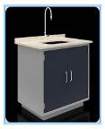 | 12 | unit
NM | Layanan Administrasi dan Perkuliahan
 | Printer dotmatrix | EPSON Printer [LX-310]  Printing Method Impact dot matrix  Pixel Resolutions Max. 9 pin, 160 columns max, up to 240 x 216 dpi  Print Speed Black  High Speed Draft10/12/15 cpi : 347 / 357 cps  High Speed Draft Condensed17/20 cpi : 383 / 298 cps  Draft10/12/15 cpi : 260 / 312 / 223 cps  Draft Condensed17/20 cpi : 222 / 260 cps  Draft Emphasized10 cpi : 130 cps  NLQ10/12/15/17/20 cpi : 65 / 78 / 55 / 47 / 56 cps  Antarmuka / Interface  USB 2.0 Full-Speed  Bi-directional parallel interface (IEEE-1284 nibble mode supported)  Ink Catridge Black Fabric Ribbon Cartridge (Black)  O/S Compatibility Microsoft® Windows® 2000 / XP / 7, Microsoft® Windows Vista®  Ukuran Kertas  Cut Sheet (Single Sheet)  Length : 100 - 364mm  Width : 100 - 257mm  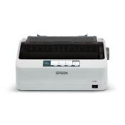 | 3 | Unit
 | Digital camcorder | Panasonic camcorder HC-V785  Spesifikasi :  - 12.76 megapixels  - 1/2.3-inch BSI MOS Sensor  - F1.8 (Wide) / F3.6 (Tele)  - 20x Optical Zoom  - 5 Axis Hybrid OIS+  - Full HD  - Slow Motion Movie  - 3.0-inch Wide LCD monitor  - AV  - HDMI  - Microphone  - Headphone  - USB 2.0  - SD/SDHC/SDXC Memory Card  - 65 x 73 x 139 mm  - 32 GB Memory Card  - Tas kamera  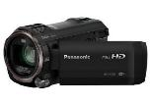 | 1 | Unit
 | Tripod | Manfrotto tripod COMPACT Action  Spesifikasi :  Round shaped new design quick release plate  The newly designed Quick Release Plate that can be worn by hand can quickly mount the camera  A compact body that can be selected from three colors achieves maximum load capacity of 1.5 kg  5 steps / total stretching height 155 cm / elongation 133 cm / storage height 45.3 cm / self weight 1.16 kg / maximum load capacity 1.5 kg.  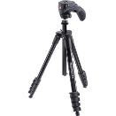 | 1 | Unit
 | Telepon wireless | PANASONIC KX-TGC 212 - Telepon / Telephone Wireless Cordless  Panasonic Cordless Wireless Phone KX-TGC212 Silver Telepon merupakan telepon dengan performa yang sangat baik. Telepon tanpa kabel yang Anda dapat digunakan pada perkantoran ataupun di rumah untuk keperluan pribadi. Telepon ini didesign minimalis dengan speakerphone ,120 names & number phone book , clock, alarm & keylock cocok untuk menemani bisnis anda.  Display and Keypad  1.6" Display  Backlight colour : Amber  Illuminated keypad  Easy to Use Handset  Call Management  Nuisance Call Blocking: 50 numbers  Anonymous Call Blocking  Do Not Disturb  Caller ID  Caller ID Memory: 50 stations  Call Share  Conference Call with outside Line  Intercom (Handset to Handset)  Any Key Answer  Mute (Soft key)  Redial Memory: 10  Handset Features  Date & time display  Alarm Clock  Key Lock  Name and caller ID  Call log entries : 50  Phonebook : 50 names and numbers  Base functions & other facts:  Eco Mode  GAP Compatible  Standby time : Up to 170 hours  Talk time : Up to 20 hours  2 Handsets  Garansi resmi 2 Tahun  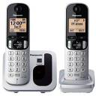 | 10 | Unit
 | Dispenser | DISPENSER ELECTRIC  Spesifikasi :  Refrigerant R-134a/23g  Rate Current 2.5A  TEMPERATURE  Hot 80 - 92 Celcius  Cold 3 - 10 Celcius  POWER CONSUMPTION  Max Input 485 Watt  Heater 185 or 385 Watt  Max Cooling 100 Watt  Dimension 320 x 380 x 1028 mm  Weight 15.6 kg  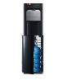 | 5 | Unit
 | DJI Mavic Pro Fly More Combo Camera Drone with Remote Controller | Spesifikasi :  Brand : DJI  Format : RecordJPEG, DNG, MPEG-4 AVC, H.264  Bahasa : -  Sensor : CMOS  Lensa : 35mm Format Equivalent f/2.2  Pixel : 12.35 MP  Berat : 743g  Interface : APP / Live View, Remote Controller  Optical Zoom : -  Sumber Daya : LiPo 3s Battery  Lain-lain : Ekstra Fly More Combo : Battery Charging HUB Battery To Power Bank Adaptor 2 pcs Intelligent Flight battery Car Charger 4 pcs Folding Propellers DJI Shoulder Bag  Digital Zoom :-  Wireless : Ada  Pelindung Lensa : Ya  Dimensi Produk : 83mm x 83mm x 198mmLCD-Konsumsi Daya : 43.6 Wh  Isi dalam box :  DJI Mavic Pro Aircraft  - Remote Controller  - 4 pcs Propeller Pair  - Charger  - Power Cable  - Micro USB  - 2 pcs RC Cable  - Manuals  Ekstra Fly More Combo :  - Battery Charging HUB  - Battery To Power Bank Adaptor  - 2 pcs Intelligent Flight battery  - Car Charger  - 4 pcs Folding Propellers  - DJI Shoulder Bag  Fitur :  - Memiliki ukuran yang compact dan ringkas  - Jarak Terbang +/- 7 Km  - Kamera Drone 12 MP Gimbal Stabilized  - Bisa merekam Video 4K  - Durasi Terbang maksimum 27 menit  - Fitur : ActiveTrack, TapFly dan fitur pintar lainnya  - FlightAutonomy dengan Obstacle Detection (mampu menghindari rintangan secara otomatis)  - GPS dan Vision Position Based Navigation  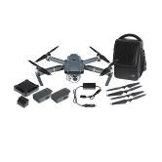 | 1 | Unit
Jumlah
Pejabat Pembuat Komitmen,

Ach. Nashichuddin, MA
NIP 19730705 200003 1 002

