
KEMENTERIAN AGAMA
UNIVERSITAS ISLAM NEGERI MAULANA MALIK IBRAHIM MALANG
Jl. Gajayana No. 50 Malang 65144, Telp. (0341) 551354, Fax. (0341) 572533
Website : www.uin-malang.ac.id E-mail : info@uin-malang.ac.id

Nomor : Un.03/KS.01.7/3031/2017 21 Agustus 2017
Lampiran : 1 (satu) bendel
Perihal : Permintaan Informasi Harga

Kepada Yth.
............................................................................................
di
‘- T e m p a t –

Dengan hormat,.
Sehubungan rencana realisasi pelaksanaan pekerjaan Pengadaan Sarana Prasrana Laboratorium Biologi Farmasi UIN Maulana Malik Ibrahim Malang Tahun Anggaran 2017, bersama ini kami bermaksud agar perusahaan saudara memberikan informasi tentang harga barang sesuai dengan Rencana Anggaran Biaya (RAB) yang kami lampirkan dalam surat ini untuk data dukung survey pembuatan HPS (Harga Perkiraan Sendiri) Lelang Pengadaan Peralatan dan Mesin Lab. Biologi Farmasi.
Apabila informasi harga yang saudara berikan sesuai dan kami nilai wajar, maka kami akan memberi kesempatan perusahaan saudara untuk membuat penawaran terhadap pekerjaaan tersebut.
Kami harap data barang dapat kami terima paling lambat pada :
Hari : Selasa
Tanggal : 05 September 2017
Pukul : 10.00 WIB
Tempat : Kantor Unit Layanan Pengadaan
Lantai II Gedung Rektorat UIN Maulana Malik Ibrahim Malang
Jl. Gajayana No. 50 Malang (0341) 570886

Surat tentang informasi harga barang tersebut, ditujukan:
Kepada Yth:
Pejabat Pembuat Komitmen FKIK
Universitas Islam Negeri Maulana Malik Ibrahim Malang
Jalan Gajayana No. 50 Malang

Adapun informasi harga tersebut bisa dikirim via e-mail ke : ulp@uin-malang.ac.idatau ulp_uinmalang@kemenag.go.id atau bisa dikirim langsung ke kantor ULP atau di Fax ke (0341) 570886
Demikian atas perhatian dan kerjasamanya yang baik, kami sampaikan terima kasih.
Pejabat Pembuat Komitmen,

Ach. Nashichuddin, MA
NIP 19730705 200003 1 002

Lampiran :
Surat Permintaan Informasi Harga Barang
Nomor : Un.03/KS.01.7/3031/2017
Tanggal : 21 Agustus 2017

Rincian Anggaran Biaya (RAB)

Pekerjaan : Pengadaan Sarana Prasarana Laboratorium Biologi Farmasi
Lokasi : Fakultas Kedokteran Dan Ilmu-Ilmu Kesehatan
Tahun Anggaran : 2017

No | Nama Barang, Spesifikasi dan Gambar | Volume |  | Harga (Rp) | Jumlah (Rp)
1. | ROTARY EVAPORATOR HEIDOLPH  Hei- VAP Precision Motor Lift G3 Vertical  Most demanding applications and the finest integrated vacuum control capacities  Merk : HEIDOLPH-Germany CAT : 564-01300-00  Experience the advantages of our large digital 4.3” color graphic display which features all parameter, integrated vacuum controlled and includes program for automated distillations. Make your life easier by utilizing the integrated software support which leads you through the capacities of the evaporator. For data management Hei-Vap Precision models feature a USB interface  Technical Specifications – Rotary Evaporator  Hand/Motor Lift : Motor lift  Height adjustment : 155 mm  Rotation speed : 20-280 rpm  Rotation speed setting : 4.3” LCD color graphic display  Drive : Brushless DC motor with electronic speed control  Heating capacity : 1.300 W  Temp. range heating bath : 20 -210 °C  Temp. accuracy bath : ± 1 °C  Overheat protection bath : Cut-off at 5 °C over set temperature via separate PT 1000  Bath temp. setting : 4.3” LCD color graphic display  Heating bath temp. control : Electronic/digital  Secondary overtemp. Cut-off : 250 °C  Material heating bath : Stainless steel AISI 316 L  Diameter heating bath : 255 mm  Volume heating bath : 4.5 L  Display vapor temperature : Yes  Required accessories : Vapor temperature sensor  Remote control function  - Lift : Yes  - Start rotation : Yes  - Start Vacuum : Yes  - Start heating bath : Yes  Supply power : 1.400 W  Wight (w/o glass assembly) : 17 Kg  Size (l x w x h) : 395 x 490 x 430 (mm)  Protection glass (DIN EN 60529) : IP 20  Operation conditions : 0 - 40° at 80% rel. humidity  Rate of evaporation  - Toluene : 8.5  - Acetone : 5.8  - Ethanol : 3.5  - Water : 1.2  Condensing surface : 1.200 cm²  Supply voltage : 230/50/60  115/60  Complete with :  591-35000-00-1 Tube set  569-00040-00 Auto Accurate Sensor  569-00060-00 Vacuum valve  Rotavac Valve TEC  Merk : Heidolph-Germany  CAT. : 591-00160-00  Two-stage diaphragm pump made from chemically resistant materials  Suction capacity of 0.75 m3/h  The rotavac valve tec achieves an ultimate vacuum of 12 mbar  The rotavac valve tec can be combined with a condenser input : 80 W  Weight : 6 kg  Dimensions : 315 x 145 x 169 (L x W x H/mm)  Complete with :  569-00070-00 Woulff bottle with bracket  Water circulator type RA 8  Merk : Lauda-Germany  Cat no : LCK 1907  3 keys operation with large and brillant LED display  Automatic compressor control supplies strong cooling output up to 425 W only when needed  Easy to remove front panel via handsholds  A drain connection of the rear side of the devices makes emptying a simple job  Technical Data :  - Working temp. range : -25 . . . 100°C  - Temp. stability 20°C : 0.05 ±K  - Heater power : 1.5 kW  - Cooling output @ 20°C : 0.225 kW  - Bath volume : 5 . . . 7.5 L  - Bath Opening / Bath Depth : 165 x 177 / 160 mm  Meja  (w x d x h) : 120 x 60 x 76 cm  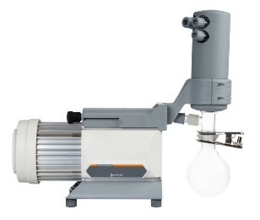  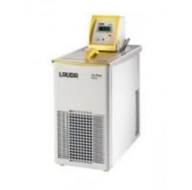  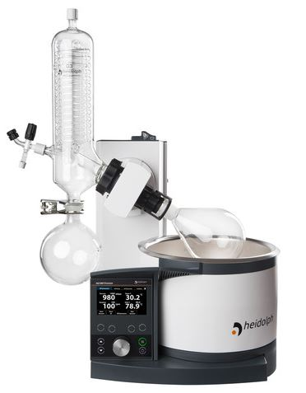  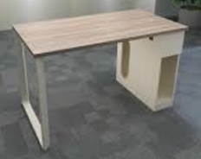 | 1 | Unit | …………… | ……………
2. | TLC PLATE HEATER, MERK: CAMAG  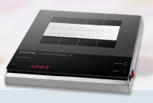  The TLC Plate Heater III is designed for heating TLC plates to a given temperature, while ensuring homogenous heating across the plate. The TLC Plate Heater III has a CERAN heating surface which is resistant to all common reagents and is easily cleaned. The 20 x 20 cm heating surface has a grid to facilitate correct positioning of the TLC plate. Programmed and actual temperature are digitally displayed. The temperature is selectable between 25 and 200 C. The plate heater is protected from overheating. | 1 | Unit | …………… | ……………
3. | TLC CHAMBER, MERK: CAMAG  Twin Trough Chamber for 10 x 10 cm plates, with stainless steel lid  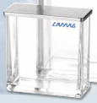 | 2 | Unit | …………… | ……………
4. | TLC VISUALIZER 2, BRAND: CAMAG CAT: 022.9810.  Reproducible high-quality images acquired under homogenous  illumination with the selected light  . Easy and intuitive operation with visionCATS  . High-dynamic-range imaging (HDRI)  . Side by side comparison of tracks originating from the same or different plates and/or different illumination modes  . Various image enhancement tools. e.g. "Spot Amplification". "Clean Plate Correction" and "Exposure Normalization"  . Image-based profile generation from reference and sample tracks, and subsequent peak integration and calibration  . New digital CCD camera with a maximum resolution of 82 µm on the plate  . USB 3.0 for easy PC connection  . Meets all requirements to be used in a cGMP/cGLP environment  . IQ/OQ qualification and 21 CFR Part 11 ready  Technical specifications  Dimensions and weight  Width: 480 mm, depth: 537 mm, height: 596 mm Net weight: 17.0 kg  Object size supported  With l2 mm lens: up to 20 x 20 cm  Light sources  2 ^{x} UV tube long wavelength (366 nm) - direct light  2 ^{x} white light tube - direct light  2 ^{x} white light tube - transmitted light  Camera type  Digital CCD camera, sensor "SONY Super HAD CCD”, HDR  Camera exposure time :  2-3 ms to l0 s, up to 60 s for HDRI, min. step size 1 µs  Connection : USB 3.0 and RS 232  Main Voltage : 100 - 240 V, 50/60 Hz, 50 W  Software for instrument control : visionCATS (2.3 or higher) on MS Windows 7  Include :  Waranty card  Installation  Operating Manual in English  CAMAG®HPTLC Software visionCATS Basic Version  Brand : CAMAG CAT : 028.0000  Including access and control of all instruments -  1 server. 1 client lnstrument Diagnostics (xQ), analytical reports -  access to method library.  Needs to be bought separately and is not included in any  Ultimate Package  CAMAG®HPTLC Software visionCATS visionCATS Ultimate  Brand : CAMAG CAT : 028.1000  Combining all CAMAG Visualizer and CAMAG Scanner Packages, including:  Visualizer High-Resolution Documentation Package (028.2100),  Scanner Multi Wavelength Package (028.3100).  Spectrum Scanning Package (028.3200) & Scanner Quantification Package ( 023.3300 ).  CAMAG TLC Software visionCATS Basic Version (028.0000) needs to be purchased separately.  PC HP 280 G3 MT IRY23PA --- New  Intel Corel5-7500 (3,4 GHz) 4GB DDR4-2133 (l x 4GB) RAM , I TB 7200 Rpm SATA, super multi DVDRW  intel HD Graphics 630 ,HP USB Keyboard and Mouse, Parallel & Serial Port, 6 in I Media Card Reader, LED Monitor 18"5 inch  Printer  Epson L120  UPS  REILLO/APC 2kva Type 902ws  Meja  (w x d x h) : 120 x 60 x 76 cm  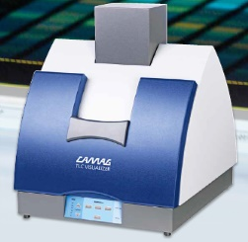 | 1 | Unit | …………… | ……………
5. | smartCUT, MERK: CAMAG  For exact cutting of TLC/HPTLC plates.  For method development, screening tasks, pre-tests etc. often small  formats of precoated layers are used. CAMAG smartCUT allows  cutting TLC and HPTLC plates into defined pieces.  Plates with a thickness up to 3 mm can be cut easily and precisely.  smartCUT does not damage the sensitive layer.  Easy handling - the required size can be read directly from the scale.  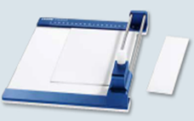  Helps saving costs on precoated plates of high quality by preventing offcuts. | 1 | Unit | …………… | ……………
6. | ULTRASONIC CLEANER, MERK: SONICA  Sweep system oscilator module, microprocessor circuit base for degassing, heating, and ultrasonics, stainless steel with special surface treatment, waterproof membrane keyboard with Ied display, sturdy handles, Tank dimension 500x300x200 mm, external dimension 600x330x410 mm, capacity 28 Liter, frequency 40 KHz, US peak power 1000 W, power heating 1000 W, stainless steel holder basket  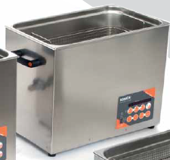 | 1 | Unit | …………… | ……………
7. | BLENDER Merk PHILIPS HR-2874  Bahan rangka : Plastik ABS  Bahan pisau : Baja antikarat  Bahan botol : SAN  Warna : abu-abu dan putih  Daya : 350 watt  Frekuensi : 50/60 Hz  Kapasitas tabung blender : 0,6 liter  Kapasitas pencacah mini : 350 ml  Kapasitas botol : 0,6 liter  Voltase : 220-240 volt  Setelan kecepatan : 1  Tempat penyimpanan kabel : ada  Pisau bisa dilepas : iya  Filter : ada  Perajang mini : ada  Botol minuman : ada  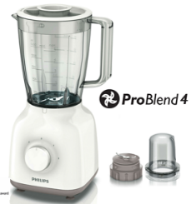 | 1 | Unit | …………… | ……………
8. | ROTOR MILL / GRINDER  Full stainless steel structure, very durable, speed ± 24000 rpm, capacity > 100 g sample, grinding results : 60-200 mesh, voltage: 110/220V, 50/60Hz, watts: 400 watts, working chamber size: ID100mm, Depth 100mm, 750ml, dimensions: ф140×290 mm, product Weight: 3.5 kg  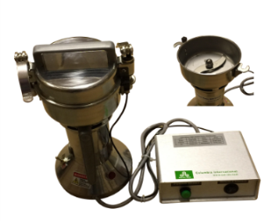 | 1 | Unit | …………… | ……………
9. | OVEN, MERK: MEMMERT  Set temperature range in °C : min. 5°C above ambient up to +80°C  Setting accuracy temperature : 0.1°C  Temperature : 2 Pt100 sensors Class A in 4-wire-circuit, mutually monitoring and taking over the performance at the same temperature value  Door : fully insulated stainless steel door with 2-point locking (compression door lock)  Internals : 2 stainless steel grids  Dimensions : w(D) x h(E) x d(F): 745 x 864 x 584 mm  Housing  Voltage Electrical load  approx. 2800 W  Voltage Electrical load  approx. 1800 W  Interior : nearly gas-tight interior  Interior : easy-to-clean interior,made of stainless steel, reinforced by deep drawn ribbing with integrated and protected large-area heating on four sides  Volume : 108 L  Dimensions W x H x D in mm : w(A) x h(B) x d(C): 560 x 480 x 400 mm  Max. number of grids/shelves : 5  Max. loading of chamber  Max. loading per grid/shelf : 20 kg  ControlCOCKPIT  Language setting : German, English, Spanish, French, Polish, Czech, Hungarian  Timer  Function HeatBALANCE : adapting the distribution of the heating performance of the upper and lower heating circuit from -50 % to +50 %  Function SetpointWAIT : the process time does not start until the set temperature is reached  Calibration : three freely selectable temperature values  Adjustable parameters  Temperature control : mechanical temperature limiter TB, protection class 1 according to DIN 12880 to switch off the heating approx. 20°C above nominal temperature  Temperature control : overtemperature monitor TWW, protection class 3.1 or adjustable temperature limiter TWB, protection class 2, selectable on display  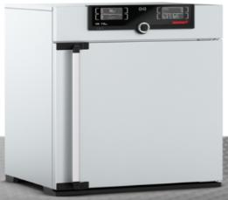 | 1 | Unit | …………… | ……………
Jumlah |  |  |  |  | ……………
Terbilang :

NB : *) harga sudah termasuk pajak

Pejabat Pembuat Komitmen,

Ach. Nashichuddin, MA
NIP 19730705 200003 1 002

