
KEMENTERIAN AGAMA
UNIVERSITAS ISLAM NEGERI MAULANA MALIK IBRAHIM MALANG
Jl. Gajayana No. 50 Malang 65144, Telp. (0341) 551354, Fax. (0341) 572533
Website : www.uin-malang.ac.id E-mail : info@uin-malang.ac.id

Nomor : Un.03/KS.01.7/3030/2017 21 Agustus 2017
Lampiran : 1 (satu) bendel
Perihal : Permintaan Informasi Harga

Kepada Yth.
............................................................................................
di
- T e m p a t –

Dengan hormat,.
Sehubungan rencana realisasi pelaksanaan pekerjaan Pengadaan Sarana Prasarana Lab. Teknologi Farmasi UIN Maulana Malik Ibrahim Malang Tahun Anggaran 2017, bersama ini kami bermaksud agar perusahaan saudara memberikan informasi tentang harga barang sesuai dengan Rencana Anggaran Biaya (RAB) yang kami lampirkan dalam surat ini untuk data dukung survey pembuatan HPS (Harga Perkiraan Sendiri) Lelang Pengadaan Peralatan dan Mesin Lab. Teknologi Farmasi.
Apabila informasi harga yang saudara berikan sesuai dan kami nilai wajar, maka kami akan memberi kesempatan perusahaan saudara untuk membuat penawaran terhadap pekerjaaan tersebut.
Kami harap data barang dapat kami terima paling lambat pada :
Hari : Selasa
Tanggal : 05 September 2017
Pukul : 10.00 WIB
Tempat : Kantor Unit Layanan Pengadaan
Lantai II Gedung Rektorat UIN Maulana Malik Ibrahim Malang
Jl. Gajayana No. 50 Malang (0341) 570886

Surat tentang informasi harga barang tersebut, ditujukan:
Kepada Yth:
Pejabat Pembuat Komitmen FKIK
Universitas Islam Negeri Maulana Malik Ibrahim Malang
Jalan Gajayana No. 50 Malang

Adapun informasi harga tersebut bisa dikirim via e-mail ke : ulp@uin-malang.ac.idatau ulp_uinmalang@kemenag.go.id atau bisa dikirim langsung ke kantor ULP atau di Fax ke (0341) 570886
Demikian atas perhatian dan kerjasamanya yang baik, kami sampaikan terima kasih.
Pejabat Pembuat Komitmen,

Ach. Nashichuddin, MA
NIP 19730705 200003 1 002

Lampiran :
Surat Permintaan Informasi Harga Barang
Nomor : Un.03/KS.01.7/3030/2017
Tanggal : 21 Agustus 2017

Rincian Anggaran Biaya (RAB)

Pekerjaan : Pengadaan Peralatan dan Mesin Lab. Teknologi Farmasi
Lokasi : Fakultas Kedokteran Dan Ilmu-Ilmu Kesehatan
Tahun Anggaran : 2017

No | Nama Barang, Spesifikasi dan Gambar | Volume |  | Harga (Rp) | Jumlah (Rp)
1. | Dispersers  Specification | 1 | Unit | …………… | ……………
  Brand : IKA, Germany
  Model : T 25 digital ULTRA-TURRAX® Package; 9024200
  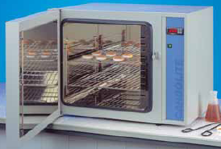
  - Motor rating input 800 W
  - Motor rating output 500 W
  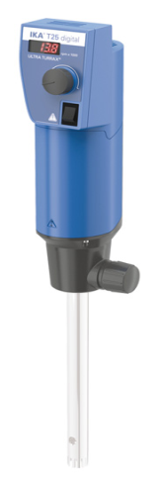
  - Volume range min. (H2O) 0.001 l
  - Volume range max. (H2O) 2 l
  - Viscosity max. 5000 mPas
  - Speed range 3000 - 25000 rpm
  - Speed deviation 1 %
  - Speed display LED
  - Speed control stepless
  - Noise without element 75 dB(A)
  - Extension arm diameter 13 mm
  - Extension arm length 160 mm
  - Process type batch
  - Timer no
  - Permissible ON time 100 %
  - Dimensions (WHD) 87 x 271 x 106 mm
  - Weight 2.5 kg
  - Permissible ambient temperature 5 - 40 °C
  - Permissible relative moisture 80 %
  - Protection class according to DIN EN 60529 IP 20
  - RS 232 interface no
  - USB interface no
  - Analog output no
  - Voltage 200 - 240 V
  - Frequency 50/60 Hz
  - Power input 800 W
  Include item:
  Dispersing Instruments
  Boss Head Clamp
  Stands
2 | HOTPLATE WITH MAGNEETIC STIRRER  This units features a digital display and allows for easy setting and monitoring value on the illuminated read out.  For your protection, an independent safety circuit will switch off heating if hotplate temperature goes above 25ºC of set temperature.  Digital speed setting from 100 to 1.400 rpm at an accuracy of 2% and temperature setting up to 300ºC.  A separate on/off switch for heating prevents an unintentional heat up. If heating is switched on, the on/off button is illuminated for visual control.  Upgrade this magnetic stirrer with the optional digital thermometer, that provides precise temperature control to give you temperature overshoot protection and reproducible results.  Technical Specifications :  Model : MR-Hei-Tec (HEIDOLPH-Germany)  Cat. 505-30000-00  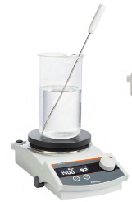With Kera-Disk® material coating, fast heat-up times and chemical resistance.  Speed, max (rpm) : 1.400  Speed accuracy (%) : ± 2  Display : digital  Heating Power(W) : 800 (600 W for 115 V-units)  Hot plate temperature (°C) : 20-300  Medium temperature, max (°C) : 250  Accuracy temperature setting (°C) : ±1  Temperature control : electronic  Temperature accuracy hotplate (°C) : ±5  Stirring capacity, max. H₂O (L) : 20  Load, max. (kg) : 25  Power consumption (W) : 820  Permissible ambient temperature(°C) : 0-40  Max. relative humidity (%) : 80  Max. permitted operation (%) : 100  Plate diameter (mm) : Ø145  Plate material : V2A  Weight (kg) : 2.9  Dimension (l x w x h) (mm) : 173 x 277 x 94  Protection class (DIN EN60529) : IP 32  Supply voltage (V/Hz) : 230/50  Kera-Disk® material coating  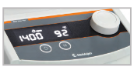
3 | Viscometer  Brand : Brookfield Cone and Plate  Model : DV-III ULTRA CPE  Spesification  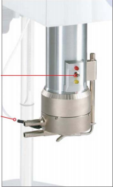  - Determine absolute viscosity : of small samples (0.5 – 2.0 mL)  - Accuracy: ±1.0% of range  - Repeatability: ±0.2%  - Electronic Gap Adjustment™  - Simplified setup  - Accurate  - Easy-to-use  - RTD Temperature Sensor in Sample Cup (Optional) provides direct measurement of sample temperature  - Control Sample Temperature using a Brookfield circulating water bath (p27)  - Rapid temperature control due to small sample size  - Temperature Range:- 10°C to 100°C  - Precise shear rates : for determining a material’s flow  curve behaviour  Include Item :  Training and Instalation  Sample cup  Wingather Software for viscometer  PC All in one : processor core i5; memory 4GB ; HDD 500GB  Color Laser Jet Printer
2. | Particle Sizing and Zeta Potential Analyzer  Spesification  - Superior optical signal (Controlled Reference Method)  delivers sensitivity and precision for measuring multi-mode  samples  - Improved chemical resistance - teflon Sample cell  - Sample cell cleaness alert  Particle Size 0.3 to 10,000 nm  Zeta Potential - 200 mV to + 200 mV  Mobility 0 to 15.5 micron/sec/volt  Molecular Weight 300 Da to 20 MDa  Hydrodynamic and Debye Plot with 2nd Viral coefcient calculation  Measurement Angle 180 deg back scatter - GRIN Lens Focusing  Detection principle Heterodyne Detection Principle  Chemical compatibility Aqueous and Non-Aqueous Sample  Volume 150 ul to 2 ml  Repeatability 1 % or better for 100 nm Polystyrene  Concentration from ppm to 40 % by volume  Temperature Control 5 to 90 deg C  Included item:  - PC : HP Pavilion All-in-One Touchsmart 24-B214D OHB : Intel Core i7-7700T; 2TB HDD; 4GB DDR4; DVD±RW; Touchscreen; 23" FHD; Win 10; Ms Office Professional Plus 2016 b.  - Color Laser Jet Printer : HP LaserJet Pro 200 Color M252n  - UPS 2 kVA; Merk : Riello Aros ; type Sentinel Pro SEP2200  - Meja besi: ukuran 190 cm x 80 cm x 75 cm; dengan Granit dengan tebal 1 cm menutup meja besi.  - Standard for Size  - Standard for Zeta Potential  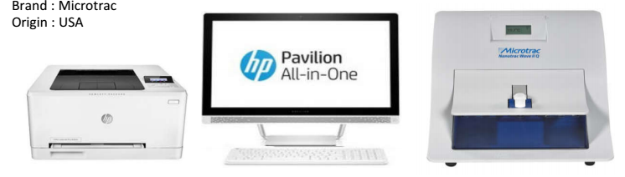 | 1 | Unit | …………… | ……………
  Brand : Microtrac, USA
  Model : NANOTRAC WAVE II
Jumlah |  |  |  |  | ……………
Terbilang :
NB : *) harga sudah termasuk pajak

Pejabat Pembuat Komitmen,

Ach. Nashichuddin, MA
NIP 19730705 200003 1 002

