
KEMENTERIAN AGAMA
UNIVERSITAS ISLAM NEGERI MAULANA MALIK IBRAHIM MALANG
Jl. Gajayana No. 50 Malang 65144, Telp. (0341) 551354, Fax. (0341) 572533
Website : www.uin-malang.ac.id E-mail : info@uin-malang.ac.id
Nomor : Un.03. /KS.01.7/4062/2017 3 Nopember 2017
Lampiran : 1 (satu)lembar
Perihal : Permintaan Informasi Harga Barang

Kepada Yth.
............................................................................................
di
‘- T e m p a t –

Dengan hormat,
Sehubungan rencana realisasi pelaksanaan kegiatan Pengadaan Belanja Modal Sarana Prasarana Laboratorium Psikologi (AUN-QA)_(Penggunaan Saldo) UIN Maulana Malik Ibrahim Malang, bersama ini kami bermaksud agar perusahaan saudara memberikan informasi tentang harga barang sesuai dengan daftar spesifikasi barang yang kami lampirkan dalam surat ini.
Informasi harga yang saudara berikan akan kami gunakan untuk membuat HPS lelang.
Kami harap data barang dapat kami terima paling lambat pada :
Hari : Selasa
Tanggal : 7 Nopember 2017
Tempat : Unit Layanan Pengadaan
Lantai II Gedung Rektorat UIN Maulana Malik Ibrahim Malang
Jl. Gajayana No. 50 Malang (0341) 570886

Adapun informasi harga tersebut bisa dikirim ke kantor ULP, di fax di no (0341) 570886 dan via e-mail ke : ulp@uin-malang.ac.id atau ulp_uinmalang@kemenag.go.id.
Surat ditujukan kepada :
Pejabat Pembuat Komitmen Kantor Pusat
UIN Maulana Malik Ibrahim Malang
Jl. Gajayana 50 Malang 65144
Demikian atas perhatian dan kerjasamanya yang baik, kami sampaikan terima kasih.

Pejabat Pembuat Komitmen,

Dr. Siti Mahmudah, M.Si
NIP 19671029 199403 2 001

Lampiran :
Surat Permintaan Informasi Harga Barang
Nomor : Un.03/KS.01.7/4062/2017
Tanggal : 3 Nopember 2017

Rincian Anggaran Biaya (RAB)

Pekerjaan : Pengadaaan Modal Sarana Prasarana Laboratorium Psikologi (AUN-QA)_(Penggunaan Saldo)
Lokasi : UIN Maulana Malik Ibrahim Malang
Tahun Anggaran : 2017

No. | Nama Barang | Spesifikasi | Gambar | Volume |  | Harga Satuan |  | Jumlah
Sarana Prasarana Laboratorium Psikologi (AUN-QA) Penggunaan Saldo

1 | LCD Proyektor | EPSON Projector [EB-X300]  Sistem Projector • 3LCD Technology  Resolusi Native • XGA (1024 x 768)  Brightness • 2800 Lumens ANSI  Rasio Kontras • 15,000:1  Rasio Besaran (Zoom) • 1.0 - 1.2  Tipe Lampu • Type : 200W UHE  • Life (Normal/Eco) : 5,000 hours / 10,000 hours  Input • D-Sub 15 pin : 1 (Blue molding)  • Composite : RCA x 1 (Yellow)  • S-Video : 1  • HDMI : 1 (MHL not supported)  • 2 RCA (White/Red) : 1  Daya / Power • 100 - 240 V AC ±10%, 50/60 Hz  Konsumsi Daya • Lamp On (Normal / Eco) : 277W / 207W  • Standby (Network On / Off) : 2.4W / 0.26W | 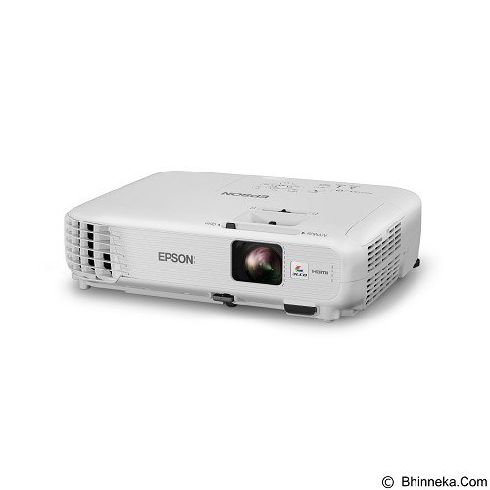 | 2 | Unit
2 | Laptop | HP Business ProBook 440 G4  Platform Notebook  Tipe Prosesor Intel Core i5  Processor Onboard • Intel® Core™ i5-7200U Processor (2.5 GHz, 3M Cache)  o up to 3.10 GHz  Memori Standar 4GB DDR4  Tipe Grafis Integrated  Ukuran Layar 14 Inch  Resolusi Layar 1366 x 768  Audio Integrated  Speaker Integrated  Kapasitas Penyimpanan 256 GB SSD  Networking Integrated  Wireless Network Type Integrated  Wireless Bluetooth Integrated  Keyboard • Spill Resistant Backlit Keyboard  Ragam Input Device Touchpad  Antarmuka / Interface • 1 USB 2.0 (power port)  • 1 USB 3.0  • 1 USB 3.0 Type-C™ port  • 1 HDMI  • 1 RJ-45  • 1 VGA  • 1 headphone/microphone combo  • 1 AC power  Sistem Operasi Microsoft Windows 10 Pro  Baterai 3 Cell  Daya Tahan Baterai • 48 WHr Long Life Prismatic Battery  Daya / Power External AC Adapter  Dimensi (PTL) • 34.32 x 23.90 x 2.03 cm  Berat Produk • 1.64 Kg  Lain-lain • Fingerprint Reader | 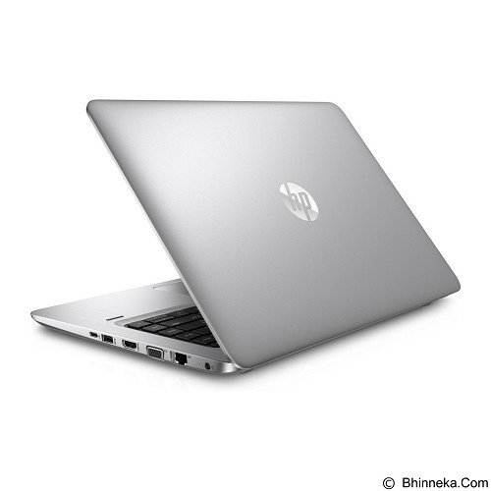 | 4 | Unit
3 | TV | SAMSUNG 50 Inch Smart TV UHD [UA50MU6100] + kabel HDMI 20 mtr  Tipe Layar LED TV  Ukuran Layar 50 Inch  Resolusi Layar 3840 x 2160 (Ultra HD)  Input / Output • 3 x HDMI  • 2 x USB  • Component In (Y/Pb/Pr): 1  • Composite In (AV): 1(Common Use for Component Y)  • Digital Audio Out (Optical): 1  • RF In (Terrestrial / Cable input / Satellite input): 1/1(Common Use for Terrestrial)/0  • HDMI A / Return Ch. Support: Yes  • HDMI Quick Switch: Yes  Audio • Dolby Digital Plus: Yes  • DTS Codec: Yes  • Sound Output (RMS): 20W  • Speaker Type: 2CH(Down Firing w/Bass Reflex)  • Multiroom Link: Yes  Video • Picture Engine: UHD Up-Scaling  • Motion Rate: MR 100  • PQI (Picture Quality Index):1300  • Dynamic Contrast Ratio: Mega Contrast  • Micro Dimming: UHD Dimming  • Wide Color Enhancer (Plus): Yes  • PurColor: Yes  • Auto Motion Plus: Yes  • Film Mode: Yes  • HDR (High Dynamic Range): HDR  Koneksi Nirkabel • Ethernet (LAN): Yes  • Wireless LAN Built-in: Yes  • Anynet+ (HDMI-CEC): Yes  Konsumsi Daya • Power Consumption (Max): 145 W  Spesifikasi Tambahan:  Software Program Informasi | 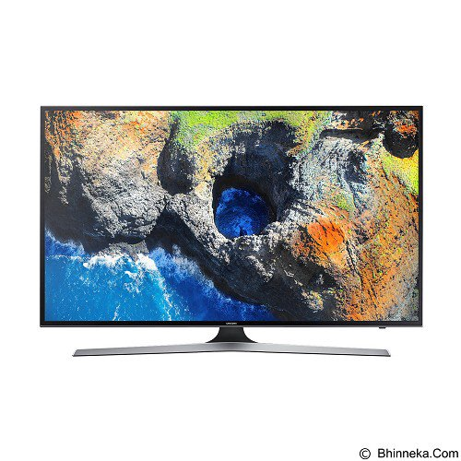 | 1 | Unit
4 | Scaner Autofedeer | FUJITSU Scan Partner [SP-1130]  Tipe ADF (Automatic Document Feeder)  Resolusi 600 dpi  Kecepatan • Simplex: 30 ppm (200 dpi / 300 dpi)  • Duplex: 60 ipm (200 dpi / 300 dpi)  Bit Depth • Color: 24-bit, Grayscale: 8-bit, Monochrome:1-bit  Ukuran Dokumen • Maximum: A4 Portrait (210 x 297 mm) or Legal (8.5 x 14 in.) or 8.5 x 34 in. (215.9 x 863.6 mm)  • Minimum: A8 Portrait / Landscape (52 x 74 mm)  Antarmuka / Interface • USB2.0  Sistem Operasi • Windows® 10 (32-bit/64-bit), Windows® 8.1/8 (32-bit/64-bit), Windows® 7 (32-bit/64-bit), Windows Vista® (32-bit/64-bit), Windows Server® 2016 (64-bit), Windows Server® 2012 R2 (64-bit), Windows Server® 2012 (64-bit), Windows Server® 2008 R2 (64-bit), Windows Server® 2008 (32-bit/64-bit), Linux (Ubuntu 16.04/14.04)  Daya / Power • AC 100 V to 240 V ± 10%  Konsumsi Daya • Operating: 18 W or less  • Sleep mode: 1.6 W or less  • Auto standby (OFF) mode: 0.4 W or less | 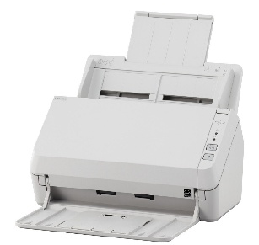 | 1 | Unit
5 | Komputer | HP All in One PC; HP 20-C302D AIO PC; i3-7100U Integrated with Kabylake Processor RAM4GB(1x4GB)DDR42133 HDD 500GB 7200RPM 3.5 Ultra Slim Tray HP 3-in-1 Media Card Reader SuperMulti DVDRW ODD Keyboard Mouse White Wired DTS STUDIO SOUND HP WLAN 802.11 b/g/n 19.5 FHD & Webcam, Windows 10 SL | 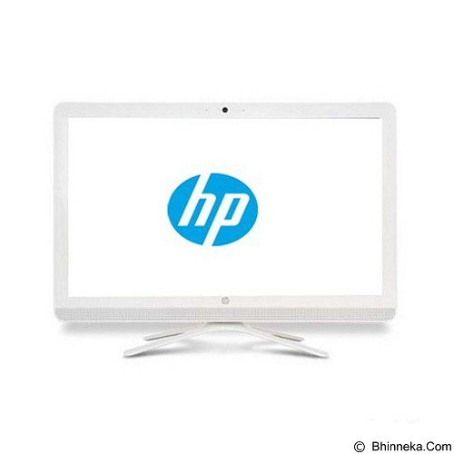 | 2 | Unit
6 | Printer | HP LaserJet Pro CP1025  Platform Colour Laser  Metode Cetak Laser  Teknologi Cetak 4-pass color laser  Maks. Besaran Kertas A4  Maks. Resolusi 600  Effective Print Resolution Up to 600 x 600 dpi  Kecepatan Cetak B/W 16 ppm  Kecepatan Cetak Warna 4 ppm  Konektivitas USB  Prosessor 266 MHz  Memori Standar 8 MB DRAM, 2 MB Flash  Maks. Memori 8 MB DRAM, 2 MB Flash  Bahasa Host-based  Input Tray #1 150 sheets | 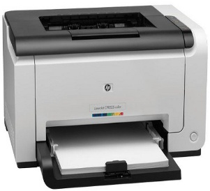 | 1 | Unit
7 | Barcode Scanner | SOLUTION BS100  Resolusi Resolution : 0.10mm (4mil)  Kecepatan • Reading speed : 120 times/second  • Reading preciseness : 0.40-0.825mm  • Reading distance : 5~30cm  Antarmuka / Interface USB | 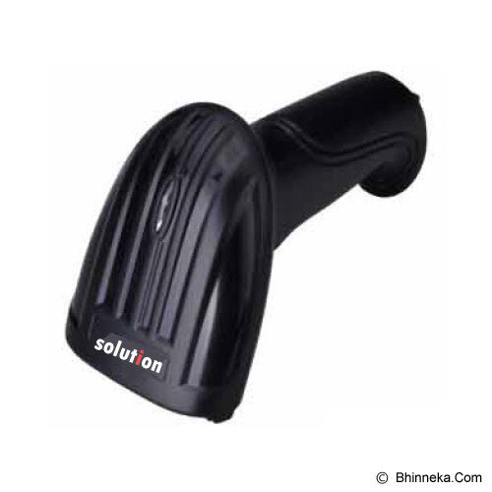 | 1 | Unit
Laboratorium Pengembangan Alat Ukur Psikologi (AUN-QA) Penggunaan Saldo
1 | Komputer | HP All in One PC; HP 20-C302D AIO PC; i3-7100U Integrated with Kabylake Processor RAM4GB(1x4GB)DDR42133 HDD 500GB 7200RPM 3.5 Ultra Slim Tray HP 3-in-1 Media Card Reader SuperMulti DVDRW ODD Keyboard Mouse White Wired DTS STUDIO SOUND HP WLAN 802.11 b/g/n 19.5 FHD & Webcam, Windows 10 SL, Ups 600V + Intalasi LAN (Hub. 24 Port HP 2 bh, Kabel LAN Balden, conector LAN, Instalasi LAN, dan Instalasi Listrik, Komputer Network Ready to use dalam ruangan) |  | 30 | unit
2 | Komputer Server | DELL PowerEdge T30 (Microtower)  Intel(R) Xeon(R) E3-1225 v5 Processor 3.3GHz 8M Cache,4C/4T,Turbo,80W,TPM  Heat Sink Dell PowerEdge T30  8GB DDR4 UDIMM, 2133 MT/s, ECC  1TB 7.2K Entry SATA 3.5in Cabled Hard Drive  DVD+/-RW,SATA,8X,9.5  Single Power Supply, 290W, Bronze  Deskside Power Cord, 220V,2M  Intel I219-LM Gigabit Ethernet LAN 10/100/1000  Keyboard  Mouse  3 Yrs Next Business Day Onsite Service - Indo, Vn, Ph & Bru  iDRAC7 Express  600GB 2.5" Hyb 3.5" Carr 15K RPM, 12Gbps SAS Hot Plug Hard Drive  Monitor 19" LED | 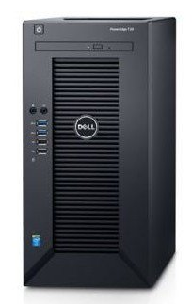 | 1 | unit
3 | Perlengkapan Laboratorium | LOGITECH 2.1 Speaker Z313 (1 Unit)  TP-LINK TL-SG1024D (1 Unit)  TP-LINK TL-SG1016D (1 Unit)  Mikrotik RB2011UiAS-2HnD-IN (1 Unit) | 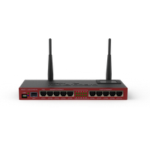  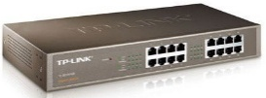  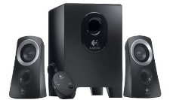  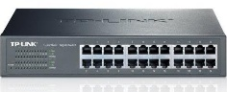 | 1 | Paket
4 | Kursi | Kursi susun bahan besi chrome, dudukan dan sandaran busa lapis kain | 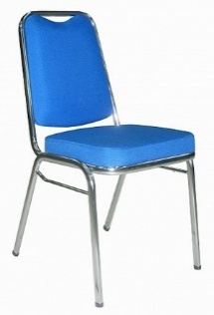 | 31 | unit
5 | Meja | Meja Komputer Rangka Besi 60 x 40 x 73,5 | 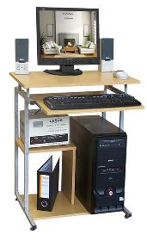 | 31 | unit
Jumlah
PPN 10%
TOTAL
Terbilang:

Pejabat Pembuat Komitmen,

Dr. Siti Mahmudah, M.Si
NIP 19671029 199403 2 001

