 | KEMENTERIAN AGAMA  UNIVERSITAS ISLAM NEGERI MAULANA MALIK IBRAHIM MALANG  Jl. Gajayana No. 50 Malang 65144, Telp. (0341) 551354, Fax. (0341) 572533  Website : www.uin-malang.ac.id E-mail : info@uin-malang.ac.id
Nomor : Un.03/KS.01.7/3712/2017 10 Oktober 2017
Lampiran : 1 (satu) bendel
Perihal : Permintaan Informasi Harga Barang

Kepada Yth.
............................................................................................
di
‘- T e m p a t –

Dengan hormat,
Sehubungan rencana realisasi pelaksanaan pekerjaan Pengadaan Alat Kesehatan Unit Layanan Kesehatan FKIK UIN Maulana Malik Ibrahim Malang Tahun Anggaran 2017, bersama ini kami bermaksud agar perusahaan saudara memberikan informasi tentang harga barang sesuai dengan Rencana Anggaran Biaya (RAB) yang kami lampirkan dalam surat ini.
Apabila informasi harga yang saudara berikan sesuai dan kami nilai wajar, maka kami akan memberi kesempatan perusahaan saudara untuk membuat penawaran terhadap pekerjaaan tersebut.
Kami harap data barang dapat kami terima paling lambat pada :
Hari : Rabu
Tanggal : 18 Oktober 2017
Jam : 14.00 WIB
Tempat : Unit Layanan Pengadaan
Lantai II Gedung Rektorat UIN Maulana Malik Ibrahim Malang
Jl. Gajayana No. 50 Malang (0341) 570886

Adapun informasi harga tersebut bisa dikirim ke kantor ULP atau via e-mail ke : ulp@uin-malang.ac.id/ ulp_uinmalang@kemenag.go.id.
Demikian atas perhatian dan kerjasamanya yang baik, kami sampaikan terima kasih.

Pejabat Pembuat Komitmen,

Ach. Nashichuddin, MA
NIP 19730705 20000 3 1 002
Lampiran :
Surat Permintaan Informasi Harga Barang
Nomor : Un.03/KS.01.7/3712/2017
Tanggal : 10 Oktober 2017

Rincian Anggaran Biaya (RAB)

Pekerjaan : Pengadaan Alat Kesehatan
Lokasi : FKIK UIN Maulana Malik Ibrahim Malang
Tahun Anggaran : 2017

No | Nama Barang |  | Spesifikasi |  |  | Volume |  |  |  | Harga Satuan |  | Jumlah
Unit Layanan Kesehatan
1 | Lemari Instrumen |  | Lemari Instrumen 2 Pintu  Dimensi : 90x40x170 cm  Konstruksi : Plat MS, Kaca 5 mm  Finishing : Epoxy Powder Coating  Aksesoris : 3 Shelf Glasses (Adjustable High) |  |  | 4 |  | buah
2 | Trolley Instrumen |  | Instrument Trolley S/S Tanpa laci  2 rak  Aksesoris : Roda 2”  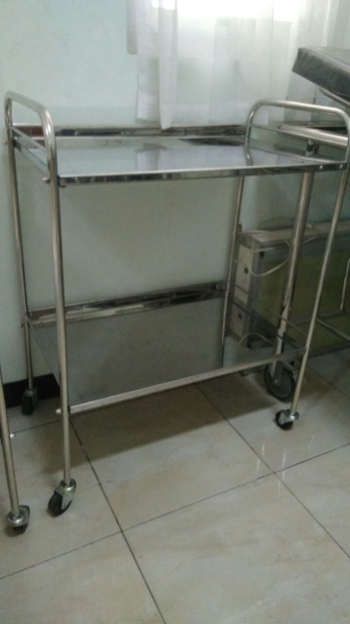 |  |  | 4 |  | Unit
3 | Tensimeter Standing |  | Reister  Nova Presameter  Specification :  Maximum error tolerance of +/- 2 mmHg  99.99% pure mercury  Precision glass column internal diameter 4.2 mm +/- 0.2 mm (0.16 in +/- 0.008 in)  Precision air release valve, wear-free and features fine regulation  Microfilters protect the measuring system and against mercury pollution  Two-tube bladder cuffs with metal screw-type connectors  Coil tubing extendible up to 3 m (9 ft 10 in)  Easy-to-read scale up to 300 mmHg  Mercury lock  Large torage compartment for cuff + bulb with meal fixture for bulb  Cleaning device for glass column  Full range of bladder cuff sizes and designs  Lightgrey finish  Height 1.05 m (41.3 in), extendible to 1.30 m (51.2 in)  Sturdy mobile base made of fibreglass with a chrome plated pole: diameter 53 cm (20.9 in) with easy to move low friction castors |  |  | 3 |  | Unit
4 | Tandu Lipat |  | GEA  Dimensi Produk: 2210 x 530 x 150mm  Dimensi Produk terlipat: 1100 x 180 x 220mm  Berat Bersih: 6 Kg  Berat Mak simal: 159 Kg  Terdapat shield belt  Terdapat tas tandu lipat  Pegangan tandu dari bahan karet |  |  | 1 |  | Unit
5 | Tensimeter raksa dewasa |  | Reister  Nova Presameter ®  Specification:  Maximum error tolerance of +/- 3 mmHg  99.99% pure mercury  Precision glass column internal diameter 4.2 mm +/- 0.2 mm  Latex bulb with chromium plated release valve  Precision air release valve, wear-free and features fine regulation  Cotton hand-cuff with two tube latex bladder  Metal faceplate with easy to read scale up to 300 mmHg  Mercury lock  Special seal against mercury contamination |  |  | 2 |  | Unit
6 | Tensimeter raksa anak |  | Reister  Nova Presameter ®  Spesification:  Maximum error tolerance of +/- 3 mmHg  99.99% pure mercury  Precision glass column internal diameter 4.2 mm +/- 0.2 mm  Latex bulb with chromium plated release valve  Precision air release valve, wear-free and features fine regulation  Cotton hand-cuff with two tube latex bladder  Metal faceplate with easy to read scale up to 300 mmHg  Mercury lock  Special seal against mercury contamination |  |  | 1 |  | Unit
7 | Tensimeter Anak Pegas |  | ABN NYLON CUFF WITH 2 TUBE LATEX BLADDER ASSEMBLY – Child (Anak)  PRODUK SPESIFIKASI  ABN Nylon Cuff w/ 2 Tube- Manset/ Cuff :  Bladder Assembly - Berbahan Nylon dengan Logo ABN Healthcare System  Bladder :  - Berbahan Natural Latex  - 2 Tubing  No. Cat. : - Rentang Pengukuran :  265-122-025 * Child : 184 - 267 mm |  |  | 1 |  | Unit
8 | Tensimeter Dewasa Pegas |  | ABN NYLON CUFF WITH 2 TUBE LATEX BLADDER ASSEMBLY – Adult (Dewasa)  PRODUK SPESIFIKASI  ABN Nylon Cuff w/ 2 Tube- Manset/ Cuff :  Bladder Assembly - Berbahan Nylon dengan Logo ABN Healthcare System  Bladder :  - Berbahan Natural Latex  - 2 Tubing  No. Cat. : - Rentang Pengukuran :  265-122-021 * Adult : 254 - 406 mm |  |  | 2 |  | Unit
9 | Termometer anak infrared |  | 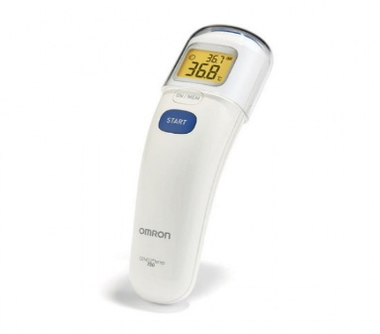  OMRON Forehead Thermometer MC-720  Spesifikasi  • Digital Forehead Thermometer  • Forehead Measurement Mode  • Room Measurement Mode  • Surface Measurement Mode  • 1 Second Quick Measurement  • 25 Memories Storage  • LCD Screen  • Touch Free  • Easy to use |  |  | 1 |  | Unit
10 | Ambubag dewasa |  | MOW Silicone Resuscitator Dewasa  Alat Bantu Pernapasan Manual  Jenis : Ambubag  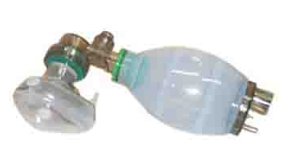 |  |  | 1 |  | Set
11 | Ambubag anak |  | MOW Silicone Resuscitator Anak  Alat Bantu Pernapasan Manual  Jenis : Ambubag |  |  | 1 |  | Set
12 | Lampu Lingkar Kepala |  | RIESTER HEADLAMP RI-FOCUS 6091  The Model 6091 ri-focus LED headlight includes 1 set of rechargeable AAA batteries and plug-in charger 230V.  SFESIFIKASI  Battery Life 4 hours,  Non-Rechargable; 90 minutes,  Rechargable Color Temperature 6,000 Kelvin  Focus Length 15.7 in (40 cm) distance, 40 mm diameter to 200 mm diameter Illumination 140 Lumen  Power AAA Rechargeable Batteries Weight 7.4 oz (210 g) without Batteries  FITUR  Infinitely adjustable focusable LED lamp  Built-in battery compartment  On/off switch on battery compartment  Charge jack for plug-in charger integrated in battery compartment  Powered by Rechargeable AAA batteries, included  Headband cleaning made easy by inner, removable and washable padding  Adjustable headband  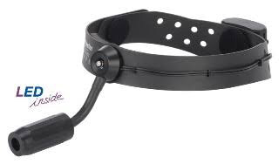 |  |  | 1 |  | Unit
13 | Ofthalmoscope |  | 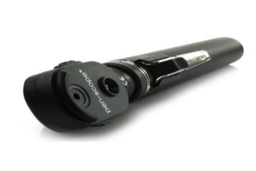  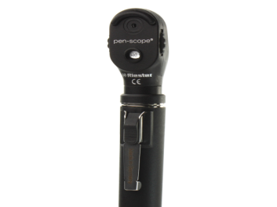  RIESTER PEN-SCOPE OPHTHALMOSCOPE  • Provided with four apertures, without red open filter.  • -40 to 0 to +40 focusing lenses for better resolution.  • With 2.5 V vacuum lamp.  • Screw fitting for fast and secure attachment to the handle.  • Sturdy adjustment ring to turn the instrument head to the ideal position on the handle.  • Extremely impact resistant casing made of glass-fibre reinforced plastic.  • Simple exchange of the lamp at the base of the instrument head. |  |  | 1 |  | Unit
14 | Otoscope |  | 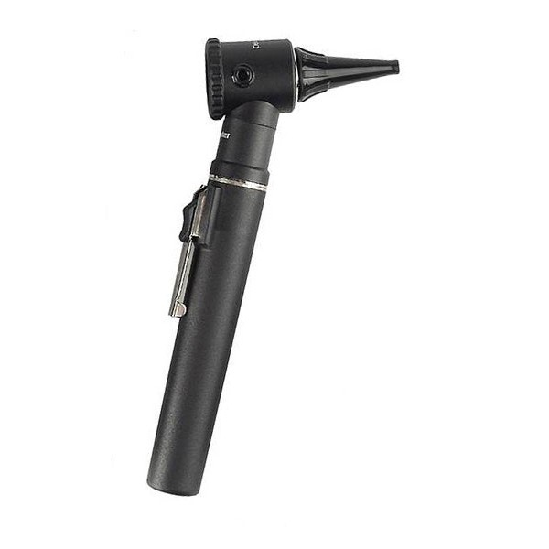  Riester Penscope Otoscope 2.7v with Pouch  • Pen-scope® Otoscope  • 2.5V vacuum lamp  • Direct illumination, with an upgraded, reflection-minimized illumination  • Removable magnifying lens with 2.5x magnification  • Possibility to insert external instruments when magnifying lens is removed  • Screw fitting for secure attachment to the handle  • Sealed system for performing pneumatic otoscopy  • Extremely impact resistant casing made of glass-fibre reinforced plastic  • Simple bulb replacement at the base of the instrument head  • Including ear specula 4mm and 2.5mm  • Supplied in a sturdy nylon pouch |  |  | 1 |  | Unit
15 | Lampu Tindakan |  | Lampu Tindakan Halogen "SURGIMED"  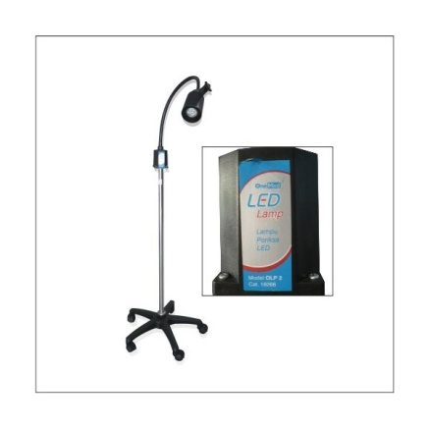 |  |  | 2 |  | Unit
16 | Fetal Doppler |  | Bistos BT 200  Spesifikasi :  - Frekuensi Tengah Ultrasound: 2 MHz  - Intensitas :< 10mW/cm2  - Sensitifitas : 10-20 minggukeatas.  - Batas penghitungandetakjantung : 50-240 bpm  - AkurasiFHR : +- 2% darinilai.  - Ukuran : 75 x 128 x 26 m |  |  | 1 |  | Unit
17 | Stetoscope |  | 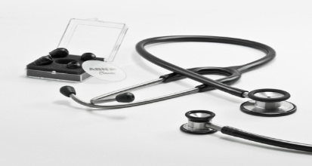  ABN Classic StethoscopDewasa (no. cat SS-021) |  |  | 2 |  | Unit
18 | Stetoscope |  | ABN Classic StethoscopAnak (no. cat SS-025)  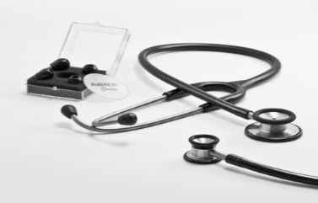 |  |  | 2 |  | Unit
19 | Mesin Cetak Kartu Berobat |  | 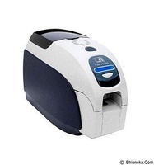  ZEBRA ZXP 3  Printer Specifications  Dye-sublimation thermal transfer direct to card  Full color or monochrome printing  Single- and dual-sided printing  700 cph monochrome single-sided  180 cph single-sided YMCKO  140 cph dual-sided YMCKOK  Edge-to-edge printing on standard CR-80 media  More Standard Features  Auto calibration of ribbon  USB connectivity  Microsoft Certified Windows drivers  Energy Star Certified  Print Touch NFC tag for online Printer documentation access  100 card covered feeder (30 mil)  45 card capacity output hopper (30 mil)  16-character LCD operator control display  300 dpi (11.8 dots/mm) print resolution  Secure lock slot |  |  | 1 |  | Unit
20 | APAR 9kg |  | 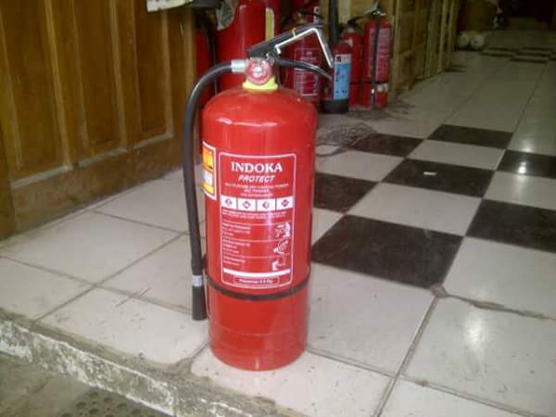  Tabung pemadam kebakaran, Jenis Chemical Dry Powder, Kapasitas 9 Kg. Efektif untuk semua kelas kebakaran ABC. |  |  | 2 |  | Unit
21 | Pulse Oximeter |  | Elitech Mobile Fox 1  - Elitech Sp02 Range : 0-99%  - Accuracy : 70-99% : +/-2% ; 70 unspesified  - Pulse Rate Range : 30-250  - Resolution : 1 BPM Accuracy : +/-2 BPM or +/-2% which one is greater  - Pulse Intensity : Bar Graph and waveform display Pulse Rate value display in 3 digits  - Alarm : Low Power indicator  - Display : 0,96' dual color OLED ( blue and yellow )  - Screen Resolution : 128 x 64 dpi  - Automatically power off within 5 seconds when no finger detect Auto saved last display format |  |  | 2 |  | Unit
Jumlah
Terbilang:

NB :
*) Harga sudah termasuk PPN

Pejabat Pembuat Komitmen,

Ach. Nashichuddin, MA
NIP 19730705 20000 3 1 002

