 | KEMENTERIAN AGAMA REPUBLIK INDONESIA  UNIVERSITAS ISLAM NEGERIMAULANA MALIK IBRAHIM MALANG  FAKULTAS SAINS DAN TEKNOLOGI  Jl. Gajayana No. 50 Malang 65144 Telp./ Faks. (0341) 558933

Nomor : 1626/FST/KU.001/7/2018
Sifat : Segera
Lampiran : 1 Bendel
Hal : PERMINTAAN INFORMASI HARGA BARANG

Yth : ________________________________________________
Di
- Tempat -

Dengan hormat,
Sehubungan rencana realisasi pelaksanaan pekerjaan Belanja Modal Peralatan dan Mesin Peralatan Laboratorium Jurusan Fisika Berupa Calorimeter Boom, Kamera Cymos, Osiloskop dll Fakultas Sains dan Teknologi Universitas Islam Negeri Maulana Malik Ibrahim Malang, bersama ini kami bermaksud agar perusahaan saudara memberikan informasi tentang harga barang sesuai dengan Rencana Anggaran Biaya (RAB) yang kami lampirkan dalam surat ini.
Apabila informasi harga yang saudara berikan sesuai dan kami nilai wajar, maka kami akan memberi kesempatan perusahaan saudara untuk membuat penawaran terhadap pekerjaaan tersebut.Kami harap informasi harga barang dapat kami terima paling lambat pada :
Hari /tanggal : Rabu, 11 Juli 2018
Jam : 10.00 WIB
Tempat : Unit Layanan Pengadaan Lantai II Gedung Rektorat UIN Maliki Malang, Jl. Gajayana 50 Malang
atau penawaran tersebut bisa dikirim via e-mail ke : ulp@uin-malang.ac.id / ulp_uinmalang@kemenag.go.id atau bisa dikirim langsung ke kantor ULP atau di Fax ke (0341) 570886

Pejabat Pembuat Komitmen Fakultas Sains dan Teknologi
UIN Maulana Malik Ibrahim Malang
Jalan Gajayana 50 Dinoyo Malang
Demikian atas perhatian dan kerjasamanya yang baik, kami sampaikan terima kasih.

Pejabat Pembuat Komitmen,

Sri Harini

Lampiran I : Surat Permintaan Informasi Harga Barang
Nomor : 1626/FST/KU.001/7/2018
Tanggal : 1 Juli 2018
Tentang :

Pekerjaan : Pengadaan Belanja Modal Peralatan dan Mesin
Berupa : Peralatan Laboratorium Jurusan Fisika Berupa Calorimeter Boom, Kamera Cymos, Osiloskop dll

NO | NAMA ALAT | SPESIFIKASI | VOLUME |  | HARGA SATUAN | TOTAL HARGA
1 | Calorimeter Boom  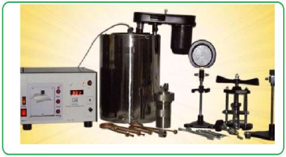 | Digital Bomb Calorimeter (Calibration Certificate by NABL approved Lab) Optional with Extra Charges 3000 + GST 18%  Brand : ATHENA  Model : DIGITAL BOMB CALORIMETER WITH BECKMANN THERMOMETER  Temperature Resolution: - 0.01 Degree Celsius  Display: - LED  Calculation: - Manual  Printer: - NO  Oxygen Filling: - Manual  1. With Following High Quality Accessories:  2. S.S. BOMB  3. Oxygen regulator Valve  4. Pellet Press  5. Hook for Lifting Bomb  6. S.S. Crucible  7. Cotton Thread  8. "O" Ring for Bomb  9. Small "O" Ring for Valve Body: 3 Pcs  10. Ignition wire:10 Mtrs  11. Schrader Valve: 4 Pcs  12. Bursting Disc: 10 Pcs  13. Outer jacket with Puff Insulation  14. Offset Stirrer (heavy duty)  15. Flexible 3 Tubes of high pressure (for gas filling)  16. Benzoic Acid of known calorific value (Photocopy of Lab Test Certificate attached)  17. Pressure Gauge  18. Becklite Combine Lid of Jacket  19. Safety Gauge  20. Connecting Lead  21. Spanner  22. Stirrer belt: 3 Pcs  23. Gas Release Pin  24. Valve key  25. Stand for Hanging Bomb Lid  26. Cylinder Valve Key  27. Compact Weighing Machine  Instalasi dan pelatihan alat | 1 | Unit | Rp | Rp
2 | Kamera Cymos  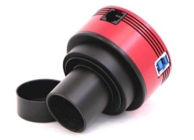 | Type : CMOS IMX174  Sensor: 1/1.2″ CMOS IMX174LLJ / IMX174LQJ  Resolution: 2.3Mega Pixels 1936×1216  Pixel Size: 5.86µm  Exposure Range: 32µs-300s  ROI: Supported  Interface: USB3.0/USB2.0  Bit rate: 12bit output(12bit ADC)  Adaptor: 2″ / 1.25″ / M42X0.75  Dimension: φ62mm X 41mm  Weight: 140g  Working Temperature: -5°C—45°C  Storage Temperature: -20°C—60°C  Working Relative Humidity: 20%—80%  Storage Relative Humidity: 20%—95%  Supported resolution  Binning 1×1:  12bit ADC:  1936X1216@128FPS  640×480@309FPS  320×240@577FPS  Binning 2×2:  968×608@128FPS  Binning 1×1:  10bit  ADC:1936X1216@164FPS  640×480@397FPS  320×240@740FPS  Binning 2×2:968×608@164FPS | 1 | Unit
3 | Pesawat atwood  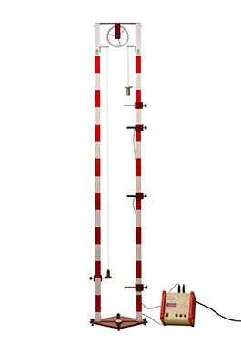 | Ukuran :  Tinggi tiang : 150 cm  Katrol : Ø 200 mm  Beban utama (Set Beban dengan Tali) : 100 g  Beban bercelah : 5 g  Bahan :  Tiang : Aluminium Beban utama (Set Beban dengan Tali) : Kuningan divernekel Beban tambahan (beban bercelah) : Aluminium Katrol : Plexiglass  Terdiri dari:  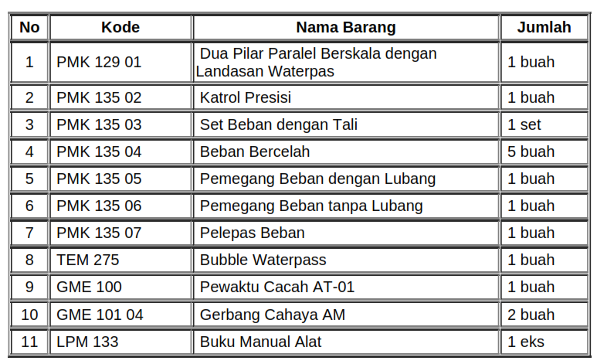 | 1 | Unit
4 | Alat Jatuh Bebas  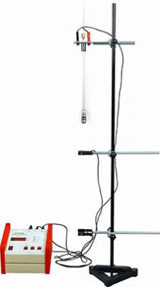 | Ukuran : (P) 122.00 x (L) 24.00 x (T) 21.00 cm  Berat : 7.300 Kg | 1 | Unit
  No | KODE | NAMA ALAT | JUMLAH
  1 | KST 25/30 | Dasar statif 190 mm, bentuk A | 1 buah
  2 | KST 30/1000 | Batang statif $∅$ 10 x 100 mm, stailess stell | 1 buah
  3 | GME 102 | Magnet pemegang | 1 buah
  4 | GME 101 03 | Gerbang cahaya FA | 2 buah
  5 | PMK 161 01 | Bola logam $∅$ 19 mm | 1 buah
  6 | PMK 160 | Pemberat timbangan | 1 buah
  7 | KSt 36/04 | Klem Boshead | 3 buah
  8 | GMM 221 | Roll meter 3 m | 1 buah
  9 | GSE 230 14 | Kabel penghubung electromagnet | 1 buah
  10 | GME 100 | Pewaktu cacah AT-01 | 1 buah
5 | Set tabung resonansi  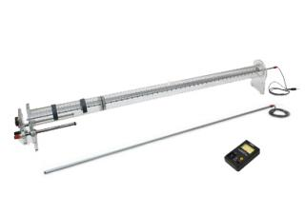 | Ukuran :Keseluruhan 1185 x 100 x 150 mm  Berat : 2.475 kg  Bahan : Flexiglass | 1 | Unit
  No | KODE | NAMA ALAT | JUMLAH
  1 | PWS 160.01 | Tabung resonansi | 1 buah
  2 | PWS 160.02 | Mikrofon | 1 buah
  3 | PWS 160.03 | Sound level meter | 1 buah
  4 | FAL 25 | Generator Frekuensi Audio:  - Rentang frekuensi: 0.1 Hz – 110 MHz  - Distorsi pada gelombang sinus kurang dari 2% (1kHz)  - Daya keluaran maksimum 3 Whatt pada beban 8 ohm  - Tegangan masukan 110/220 VAC  - Proteksi sekring (fuse) : 0,5 A (Ø 5x20 mm) | 1 buah
6 | Osiloskop  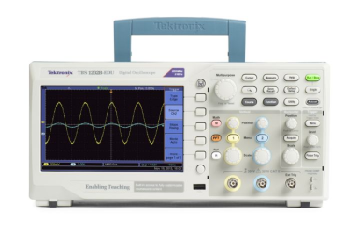 | Model TBS1052B-EDU  Bandwidth : 50 MHz  Channels : 2  Sample rate on each channel : 1.0 GS/s  Record length : 2.5k points at all-time bases  Vertical system – Analog channels  Vertical resolution : 8 bits  Input sensitivity range : 2 mV to 5 V/div on all models with calibrated fine adjustment  DC gain accuracy : ±3%, from 10 mV/div to 5 V/div  Maximum input voltage : 300 VRMS CAT II; derated at 20 dB/decade above 100 kHz to 13 Vp-p AC at 3 MHz and above  Offset range: 2 mV to 200 mV/div: ±1.8 V>200 mV to 5 V/div: ±45 V  Bandwidth limit : 20 MHz  Input coupling : AC, DC, GND  Input impedance : 1 MO in parallel with 20 pF  Vertical zoom : Vertically expand or compress a live or stopped waveform  Horizontal system — Analog channels  Time base range  50 MHz and 70 MHz models : 5 ns to 50 s/div  100MHz, 150MHz and 200MHz models : 2.5 ns to 50 s/div  Time base accuracy : 50 ppm  Horizontal zoom : Horizontally expand or compress a live or stopped waveform  Input/Output ports  USB interface : USB host port on front panel supports USB flash drives  USB device port on back of instrument supports connection to PC  GPIB interface : Optional  Data storage  Nonvolatile storage  Reference waveform display : 2.5K point reference waveforms  Waveform storage without USB flash drive : 2.5K point  Maximum USB flash drive size : 64 GB  Waveform storage with USB flash drive : 96 or more reference waveforms per 8 MB  Setups without USB flash drive : 10 front-panel setups  Setups with USB flash drive : 4000 or more front-panel setups per 8 MB  Screen images with USB flash drive :128 or more screen images per 8 MB (the number of images depends on file format selected)  Save All with USB flash drive : 12 or more Save All operations per 8 MB  A single Save All operation creates 3 to 9 files (setup, image, plus one file for each displayed waveform)  Course content : 100 MB  Acquisition system  Acquisition modes  Peak Detect : High-frequency and random glitch capture. Captures glitches as narrow as 12 ns (typical) at all time base settings from 5 µs/div to 50 s/div  Sample : Sample data only  Average : Waveform averaged, selectable: 4, 16, 64, 128  Single Sequence : Use the Single Sequence button to capture a single triggered acquisition sequence  Roll : At acquisition time base settings of >100 ms/div  Trigger system  External trigger input : Included on all models  Trigger modes : Auto, Normal, Single Sequence  Trigger types  Edge (Rising/Falling) : Conventional level-driven trigger. Positive or negative slope on any channel. Coupling selections: AC, DC, Noise Reject, HFReject, LF Reject  Video : Trigger on all lines or individual lines, odd/even or all fields from composite video, or broadcast standards (NTSC, PAL, SECAM)  Pulse Width (or Glitch) : Trigger on a pulse width less than, greater than, equal to, or not equal to, a selectable time limit ranging from 33 ns to 10 s  Trigger source : Two channel models: CH1, CH2, Ext, Ext/5, AC Line  Trigger view : Displays trigger signal while Trigger View button is depressed.  Trigger signal frequency readout : Provides a frequency readout of the trigger source.  Waveform measurements  Cursors  Types : Amplitude, Time  Measurements : ΔT, 1/ΔT, ΔV  Automatic measurements : Period, Frequency, Pos Width, Neg Width, Rise Time, Fall Time, Maximum , Minimum , Peak-Peak, Mean, RMS, Cycle RMS,  Cursor RMS, Phase, Pos Pulse Cnt, Neg Pulse Cnt, Rise Edge Cn, Fall Edge Cn, Pos Duty, Neg Duty, Amplitude, Cycle Mean,  Cursor Mean, Burst Width, Pos Overshoot, Neg Overshoot, Area, Cycle Area, High, Low, Delay RR, Delay RF, Delay FR, Delay  FF  Waveform math  Arithmetic : Add, Subtract, Multiply  Math functions : FFT  FFT : Windows: Hanning, Flat Top, Rectangular 2048 sample points  Sources : Two channel models: CH1 - CH2, CH2 - CH1, CH1 + CH2, CH1 × CH2  Autoset menu  Single-button, automatic setup of all channels for vertical, horizontal, and trigger systems, with undo autoset.  Square wave : Single cycle, multicycle, rising or falling edge  Sine wave : Single cycle, multicycle, FFT spectrum  Video (NTSC, PAL, SECAM) : Field: All, Odd, or Even Line: All or Selectable Line Number  Autorange : Automatically adjust vertical and/or horizontal oscilloscope settings when probe is moved from point to point, or when the signal  exhibits large changes.  Frequency counter  Resolution : 6 digits  Accuracy (typical) : + 51 parts per million including all frequency reference errors and +1 count errors  Frequency range : AC coupled, 10 Hz minimum to rated bandwidth  Frequency counter signal source : Pulse width or edge selected trigger source  Frequency counter measures selected trigger source at all times in pulse width and edge mode, including when the oscilloscope acquisition is halted due to changes in run status, or acquisition of a single shot event has completed.  The frequency counter does not measure pulses that do not qualify as legitimate trigger events.  Pulse Width mode: Counts pulses of enough magnitude inside the 250 ms measurement window that qualify as triggerable events (e.g. all narrow pulses in a PWM pulse train if set to "<" mode and the limit is set to a relatively small number).  Edge Trigger mode: Counts all pulses of enough magnitude.  Channels : 2 channel  Display system  Interpolation : Sin (x)/x  Waveform styles : Dots, vectors  Persistence : Off, 1 s, 2 s, 5 s, infinite  Format : YT and XY  Courseware software  System requirements The following PC configuration represents the minimum requirements needed to install the Courseware software.  Operating System : Windows XP, Windows 7, Windows 8, Linux (ubuntu 12.04, 12.10, 13.04 or fedora 18, 19)  RAM : 512 Megabytes (MB)  Disk space : 1 Gigabyte of available hard disk space  Display : XVGA 1024×768 with 120 dpi font size recommended  Removable media : CD-ROM or DVD drive  Peripherals : Keyboard and Microsoft mouse or other compatible pointing device  Power source  Power source voltage : 100 to 240 V ±10%  Power source frequency  100 V to 240 V :50 Hz to 60 Hz  115 V : 400 Hz ±10%  Power consumption : 30 W maximum  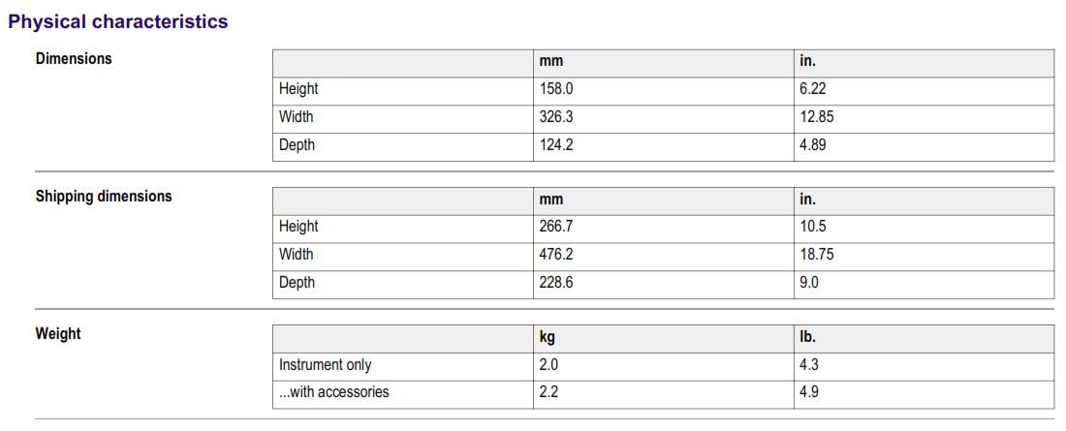  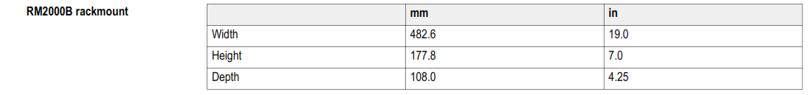  Environmental  Temperature  Operating : 0 to +50 ºC  Nonoperating : –40 to +71 ºC  Humidity  Operating and nonoperating : Up to 85% RH at or below +40 ºC  Up to 45% RH up to +50 ºC  Altitude  Operating and nonoperating : Up to 3,000 m (9,843 ft.)  Regulatory  Electromagnetic compatibility : Meets Directive 2004/108/EC, EN 61326-2-1 Class A; Australian EMC Framework  Safety : UL61010-1:2004, CSA22.2 No. 61010-1:2004, EN61010-1:2001, IEC61010-1:2001 | 4 | Unit
7 | Hotplate |  | 1 | Unit
  Catalog number | SP88857105
  Product Size | Each
  Surface Area (English) Heating | 7.25 x 7.25 in.
  Top Plate Material | Ceramic
  Electrical Requirements | 230V 50/60Hz
  Speed | 50 to 1,500rpm
  Temperature Range (Metric) | 540°C (Max Temperature)
  Surface Area (English) Heating | 7.25 x 7.25 in.
  Surface Area (Metric) Heating | 18.4 x 18.4cm
  Top Plate Material | Ceramic
  Voltage | 230V
  Hertz | 50/60Hz
  Certifications/Compliance | cCSAus, CE
  Includes | 1 power cord
  Shipping Weight (English) | 11.2 lb.
  Shipping Weight (Metric) | 5.1kg
  Stirring Range | 50 to 1,500rpm
  Warranty and Service Offering | 3 years
  Dimensions (L x W x H) | 13 x 8.2 x 3.8 in. (33 x 20.8 x 9.7cm)
  Electrical Requirements | 230V 50/60Hz
  Plug Type | EU
  Max. Temperature (Metric) | 540°C
  Type | Hotplates Stirrers
NB:
Pejabat Pembuat Komitmen,

Sri Harini
- Harga sudah termasuk PAJAK
- Dimohon untuk mencamtumkan Spesifikasi secara Lengkap
- Termasuk Instalasi dan pelatihan

