 | KEMENTERIAN AGAMA REPUBLIK INDONESIA  UNIVERSITAS ISLAM NEGERI MAULANA MALIK IBRAHIM MALANG  FAKULTAS SAINS DAN TEKNOLOGI  Kampus 1 JalanGajayana 50 Malang 65144, Telepon (0341) 558933, Faksimile (0341) 558933  Website : saintek.uin-malang.ac.id Email : saintek@uin-malang.ac.id
Nomor : 1276/FST.1/KS.01.7/05/2019 07 Mei 2019
Lampiran :1 (satu) bendel
Perihal :Permintaan Informasi Harga Barang

Kepada Yth.
............................................................................................
di
‘- T e m p a t –

Dengan hormat,
Sehubungan rencana realisasi pelaksanaan Pengadaan Revitalisasi Peralatan Laboratorium Jurusan Biologi Fakultas Sains dan Teknologi UIN Maulana Malik Ibrahim Malang, bersama ini kami bermaksud agar perusahaan saudara memberikan informasi tentang Harga barang sesuai dengan Rencana Anggaran Biaya (RAB) yang kami lampirkan dalam surat ini.
Informasi harga barang tersebut akan kami jadikan dasar survey Harga Perkiraan sendiri (HPS)
Kami harap data barang dapat kami terima paling lambat pada :
Hari : Senin
Tanggal : 27 Mei 2019
Jam : 14.00 WIB
Tempat : Fakultas Sains dan Teknologi Gedung BJ. Habibie Lantai 1
Jl. Gajayana No. 50 Malang (0341) 558933

Adapun informasi harga tersebut bisa dikirim via e-mail ke : saintek@uin-malang.ac.id atau bisa dikirim langsung ke kantor Fakultas Sains dan Teknologi telp (0341) 558933.
Demikian atas perhatian dan kerjasamanya yang baik, kami sampaikan terima kasih.
Pejabat Pembuat Komitmen,

Anton Prasetyo
Lampiran I : Surat Permintaan Informasi Harga Barang
Nomor :1276/FST/KS.01.7/05/2019
Tanggal : 07 Mei 2019
Tentang :

Pekerjaan : Pengadaan Alat Revitalisasi Jurusan Biologi Tahun 2019

No | Alat | Spesifikasi | Vol | Satuan | Jumlah
1 | Countess II FL Reusable Slide | Invitrogen Thermo Fisher Scientific  Cat. A25750 | 1 | Unit
  For use with the Countess® II FL Automated Cell Counter Only.
  The Countess II FL Reusable Slide is a greener alternative to disposable slides.
  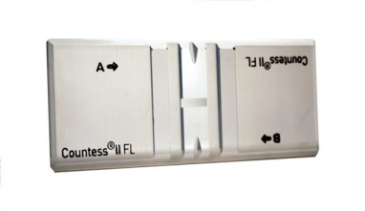
2 | Bench pH meter | Thermo Fisher Scientific  Cat. Star A1110 | 1 | Unit
  Product Size : Each
  Temperature: 41o C
  Stability: Smart Stability and smart
  averaging
  Resolution (temperature): 0.1 o C, 0.1 o F
  Temperature Probe Calibration: 1 point
  temperature offset calibration
  Warranty: 3 year meter warranty
  Weight: 0.9 kg
  AC adapter: Universal 50-60 Hz, 100-240
  VAC power adapter
  Accurancy (pH): 0.01 pH
  Accurancy (mV): 0.2 mV or 0.05% of
  reading
  Accurancy (temperature): 0.01 o C
  Battery Life: 2000 hr
  Battery Type: 4 x AA
  Description: Orion Star A111 pH
  benchop meter with stand
  Dimention: 24 cm x 18 cm x 11 cm
  Range: -2.00 to 16.00
  Display Type: LCD
  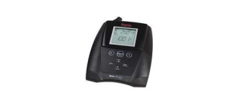
3 | Sedgewick Rafter Counting Chamber plus coverglass |  | 1 | Unit
  In accordance with APHA Standard
  Methods for the Examination of Water and Wastewater
  Cell, 50 mm x 20 mm x 1 mm deep
  Formed by four matte-surfaced strips
  cemented to 76 x 34 mm slide
  Overall thickness 3.5 mm.
  With one cover glass, 60 mm x 25 mm
  x 0.6 mm thick,
  Graticules S52 (Glass Construction)
  + Graticules S51 coverglass for
  sedgewick rafter
  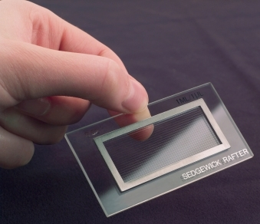
4 | Megaphone with Sirine | TOA  ZR-2015s | 1 | Unit
  Megaphone dengan pemakaian
  gantung di bahu
  Cocok untuk acara outdoor
  Mudah Dibawa Kemana-Mana
  Jangkauan sampai dengan 400m
  Power Output 15W Rated / 23W Max
  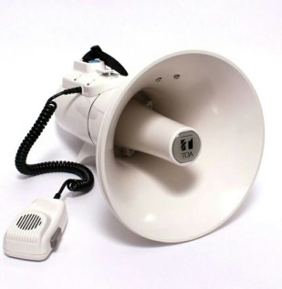
  Sirene : 20 minutes (EIAJ)
5 | Micropippette Set | Select Bio Product | 1 | Unit
  6 pcs
  SelecPette Autoclavable 0.1 - 2 ul
  SelecPette Autoclavable 0.5 - 10 ul
  SelecPette Autoclavable 2 - 20 ul
  SelecPette Autoclavable 10 - 1000 ul
  SelecPette Autoclavable 20 - 200 ul
  SelecPette Autoclavable 100 - 1000 ul
  Select Pette Autoclavable Single
  Channel Pipettes
  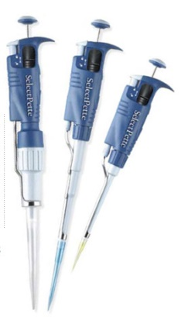
6 | Pencetak Label | Casio  KL-7400 | 1 | Unit
  Auto cutter with half cut function
  Varied labelling application
  Designed logo printing
  Large, easy to read LCD
  Barcode printing
  Numbering
  5 installed fonts
  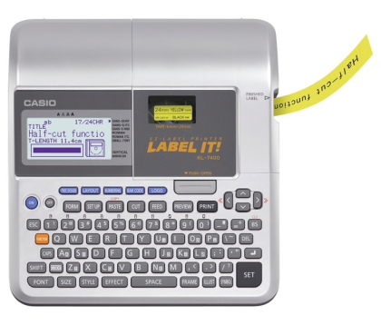
7 | Starter pH Portable | 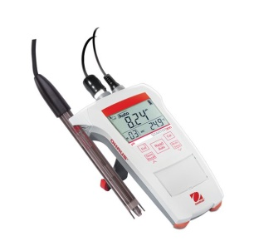  Ohaus ST 300  Cat. 83033961 | 1 | Unit
8 | Monitor TV LED | AKARI - 65" LED TV LE-65D99  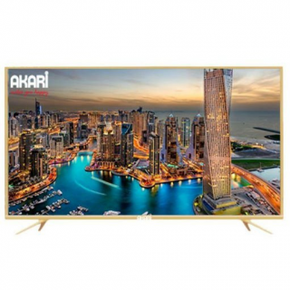 | 1 | Unit
9 | AC 1.5 PK Sharp AHA12UCY | Sharp  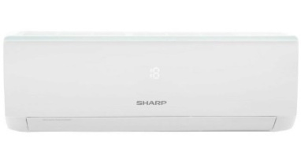 | 4 | Unit
  Capacity: 1,5 PK
  Cooling capacity: 13000 Btu
  Turbo Cooling
  Refrigrant: R32
  Eco New Refrigerant Turbo Cooling
  Self Diagnosis
  X-Fan Function
  Colour White
  Auto Swing Louver: 2 Way Auto Swing
  Anti Rust Evaporator
  Floor Area: 16 - 26m2
  Voltage : 220Volt
  Rated Current : 7.5Ampere
  Rate input: 1080 Wat
  Indoor : 12,5 kg
  Dimensi : 91x35x27 cm
  Outdoor : 32 kg
  Dimensi : 88×37×61 cm
  Include pemasangan

Pejabat Pembuat Komitmen,

Anton Prasetyo

