
KEMENTERIAN AGAMA
UNIVERSITAS ISLAM NEGERI MAULANA MALIK IBRAHIM MALANG
FAKULTAS SAINS DAN TEKNOLOGI
Jalan Gajayana 50 Malang 65144 Telepon/Faksimil (0341) 558933
Website: saintek.uin-malang.ac.id E-mail: saintek@uin-malang.ac.id

Nomor : 1786.A/FST.1/KS.01.3/07/2019 1 Juli 2019
Lampiran :1 (satu) bendel
Perihal :Permintaan Informasi Harga Barang

Kepada Yth.
............................................................................................
di
‘- T e m p a t –

Dengan hormat,
Sehubungan rencana realisasi pelaksanaan Pengadaan Belanja Modal dan Mesin Revitalisasi Peralatan Laboratorium Jurusan Teknik Arsitektur Fakultas Sains dan Teknologi UIN Maulana Malik Ibrahim Malang, bersama ini kami bermaksud agar perusahaan saudara memberikan informasi tentang harga barang sesuai dengan Rencana Anggaran Biaya (RAB) yang kami lampirkan dalam surat ini.
Informasi harga barang tersebut akan kami jadikan dasar survey Harga Perkiraan Sendiri (HPS)
Kami harap data barang dapat kami terima paling lambat pada :
Hari : Jum’at
Tanggal : 5 Juli 2019
Jam : 13.00 WIB
Tempat : Fakultas Sains dan Teknologi Gedung BJ. Habibie Lantai 1
Jl. Gajayana No. 50 Malang

Adapun informasi harga tersebut bisa dikirim via e-mail ke : saintek@uin-malang.ac.id atau bisa dikirim langsung ke kantor Fakultas Sains dan Teknologi telp (0341) 558933.

Demikian atas perhatian dan kerjasamanya yang baik, kami sampaikan terima kasih.
Pejabat Pembuat Komitmen,

TTD

Anton Prasetyo

Lampiran : Surat Permintaan Informasi Harga Nomor : 1786.A/FST.1/KS.01.3/07/2019
Tanggal : 1 Juli 2019

Pekerjaan : Pengadaan Belanja Modal Peralatan dan Mesin Jurusan Teknik Arsitektur
Lokasi : UIN Maulana Malik Ibrahim Malang
Tahun Anggaran : 2019

No. | Nama Barang  Spesifikasi Barang | Volume | Harga (Rp. | Jumlah (Rp)
1. | Laser Cutting  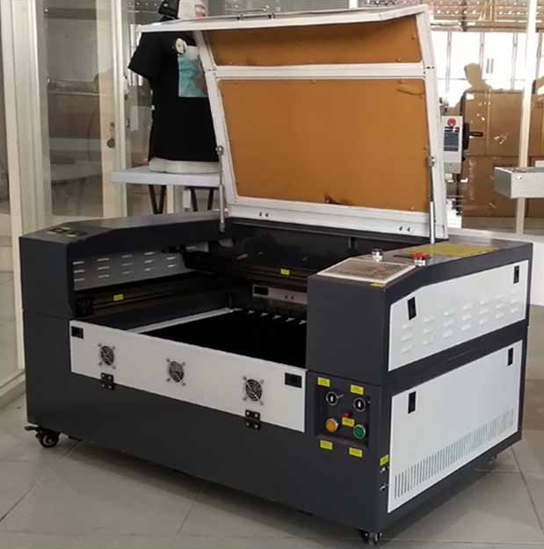  Laser Cutting  Lengkap Dengan training alat dan SOP pengggunaan alat di Jurusan Teknik Arsitektur Gd. BJ.Habibie Lt. 4.  Spesifikasi Mesin Laser Cutting Engraving JK - 4060:  Model/nama JK : 4060 mesin laser engraving  Ukuran meja kerja : 600*400mm  Laser tabung : CO2  Daya laser : 60 w  Kecepatan potong : 0-3600 mm/s  Kecepatan ukiran : 0-1000 mm/s  Resolusi : 0.01mm/1000 dpi  Dukungan fils : Bmp, HPGL, plt, dst dan ai dan lain lain  Perangkat lunak : Coreldraw Output langsung/SOFTWARE RD WORK  Tegangan listrik : Ac 110-220 v 10%, 50-60 hz  Lingkungan kerja : 0-45 C 5-95% (kelembaban)  Konsumsi daya : < 300 w  Software yang kompatibel: Coreldraw, autocad, photoshop  Dimensi : 120 (P) x 100(L) x 90(T) | 1 Unit
2 | Thermo hygrometer  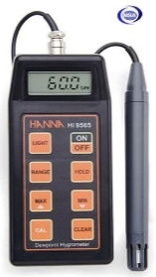  Hanna HI 9565  Range RH 20.0 to 95.0%  Range Temperature 0.0 to 60.0C (32 to 140F)  Range Dew Point -20.0 to 60.0C / -4.0 to 140.0F  Resolution RH 0.1% RH  Resolution Temperature 0.1C / 0.1F  Resolution Dew Point 0.1C / 0.1F  Accuracy RH 3% RH (50 to 85% RH)  4% RH (outside)  Accuracy Temperature 0.5C / 1F  Accuracy Dew Point 0.5C / 1F  Probe HI 70602 RH combined probe with built-in temperature sensor,  microchip and 1 m (3.3') cable (included)  Battery Type / Life 1 x 9V / approx. 250 hours of continuous use;  auto-off after 20 minutes of non-use  Environment 0 to 60C (32 to 140F); RH max 98% non-condensing  Dimensions 164 x 76 x 45 mm (6.5 x 3 x 1.8") | 1 Unit
3 | Wacom Intuos Drawing  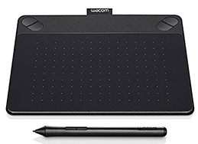  WACOM Intuos Photo PT Small Black CTH-490/K2-CX  Spesifikasi Detail Produk Tablet WACOM Intuos Photo PT Small [CTH-490/K2-CX] | 1 Unit
  Active Area | 152 x 95 mm (6.0 x 3.7 in)
  Multi-Touch | Yes
  ExpressKeys™ | Yes, 4 with application specific settings
  Pressure Levels | 1024
  Wireless Support | Yes (Sold separately)
  Resolution | 2540 lpi
  Reading Speed (Pen) | 133pps
  Pen | Intuos Pen
  Cable Included | Yes
  System Requirements | - USB port  - Internet connection  - CD/DVD-ROM drive  - Windows® 7, 8 or 10  - Mac OS X 10.8.5 or later
  Technology | Patented electromagnetic resonance method
  System Requirements | - USB port, internet connection  - Windows 8, Windows®7 SP1 or Windows® Vista SP2  - Mac OS X 10.6.8 or later (Intel® processor)
  Weight | ±50g
4 | Thermo Anemoneter  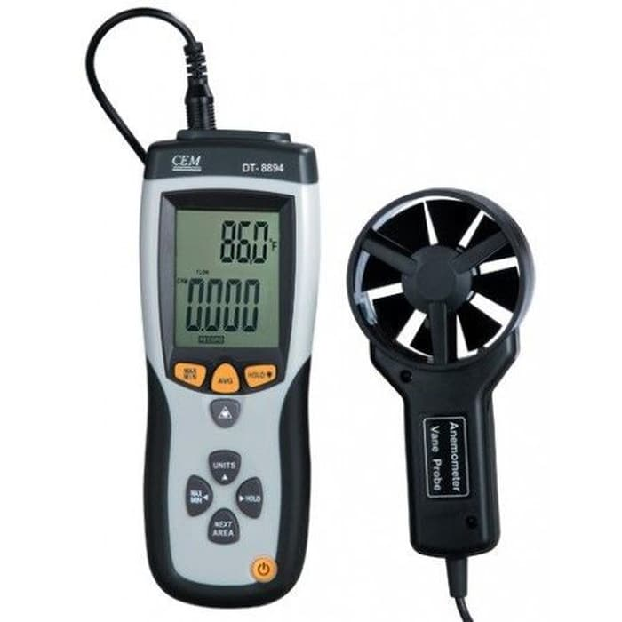  Thermo-Anemometer and Infrared Thermometer CEM DT-889  Simultaneous display of Air Flow or Air Velocity plus Ambient Temperature  Easy to set Area dimensions (cm2) are stored in the meters internal memory for the next power on  Resolution of 0.01m/sec  20 points average for Air Flow  Super large (9999 counts) LCD Backlit Display  3% velocity accuracy via low friction 2.83D (72mm) ball bearing vane wheel on 3.9ft (120cm) cable  Complete with vane sensor with 3.9ft (120cm) cable, 9V battery, and protective rubber holster  MAX/MIN, Data Hold functions | 1 Unit
5 | Light meter  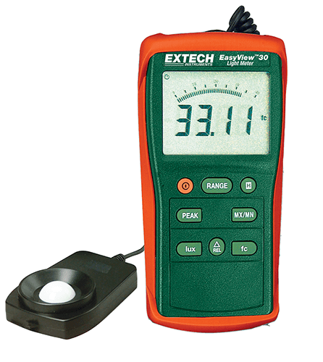  Extech EA30: EasyView™ Wide Range Light Meter  Features :  Compact and rugged design  Widest range to 40,000Fc/ 400,000Lux is ideal for outdoor applications  Large display with bargraph, Relative function for zero or difference from reference value  Peak function captures short light pulse, Data Hold and Min/Max readings  Auto power off, Zero function  Specifications Range  Display counts 4000 count LCD  Fc Range 40, 400, 4000, 40,000Fc  Lux Range 40, 400, 4000, 40,000, 400,000Lux  Max. Resolution 0.01Fc/Lux  Basic Accuracy ±3%rdg + 0.5%FS  Cosine & Color Corrected Yes  Dimensions 5.9x2.8x1.4" (150x72x33mm)  Weight 8.3oz (235g) | 1 Unit
6 | AC 1.5 PK Sharp AHA12UCY  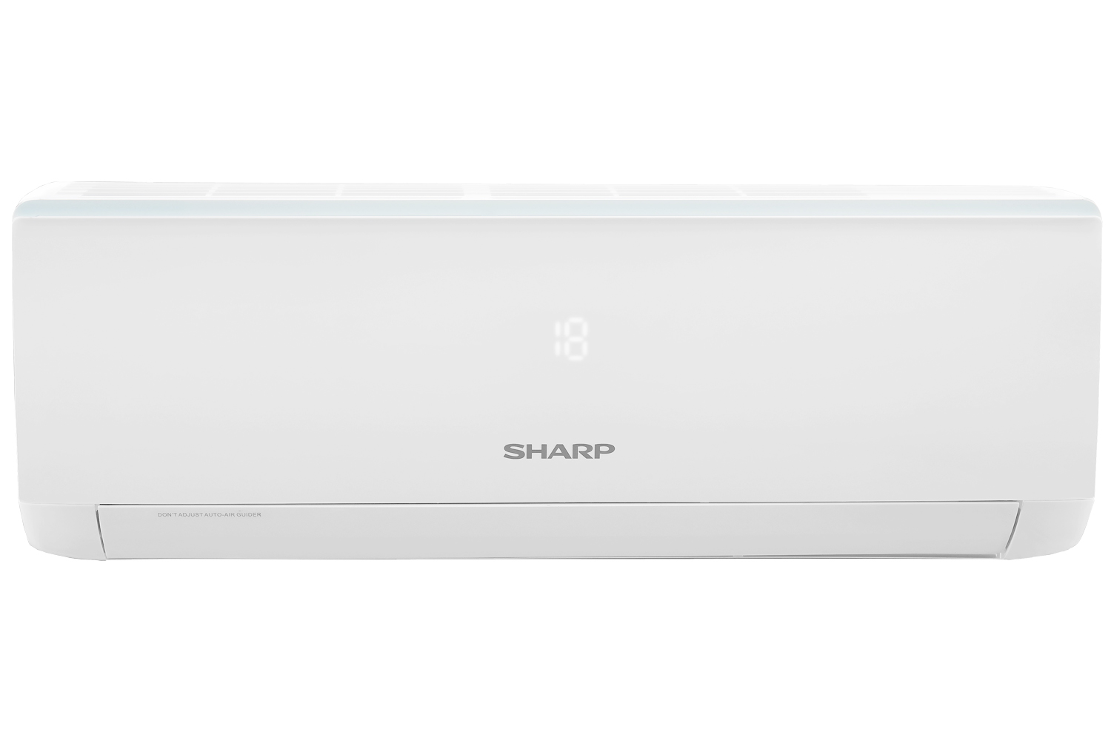  FEATURES  Colour White  Jetstream No  Coanda No  Low Wattage No  Turbo Cooling Yes  Plasmacluster No  Auto Swing Louver 2 - Way Auto Swing  Anti Rust Evaporator No  Self Cleaning Function Yes, X-Fan Function  Remote Control Yes  Coverage Floor Area 16 - 26 m2  CAPACITY  Cool 3.81 kW  Capacity 1.5 PK  Cooling Capacity 13.000 BTU  PIPE DIAMETER  Liquid Side 1/4 inch  Gas Side 1/2 inch  Refrigerant Volume R32  POWER SUPPLY  Rated Frequency 50 Hz  Rated Voltage 220 Volt  Rated Current 7.5 Ampere  Rate Input 1080 Watt  DIMENSIONS  In Door 845 x 289 x 209 mm  Out Door 848 x 540 x 320 mm  NET WEIGHT  In Door 10.5 kg  Out Door 29.5 kg  Harga sudah termasuk pajak  Sudah Termasuk Pemasangan dan kelengkapan ( bracket, pipa AC, pipa pembuangan dan kabel listrik ± 15-20M) | 4 Buah
7 | M2 NVME Urban PLanning Hardware Support  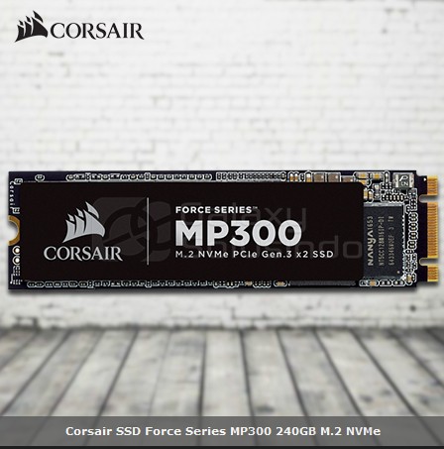  Specification :  SSD Unformatted Capacity 240 GB  SSD Smart Support Yes  Weight .055  SSD Interface PCIe Gen 3.0 x2  SSD Max Sequential Read CDM Up to 1,600MB/s  SSD Max Sequential Write CDM Up to 1,040MB/s  Max Random Write QD32 IOMeter 220K IOPS  Max Random Read QD32 IOMeter 200K IOPS  Form Factor M.2 2280  Warranty 5 Years  NAND Technology 3D TLC NAND  Storage Temperature -40°C to +85°C  SSD Operating Temperature 0°C to +70°C  SSD Shock 1500 G  Storage Humidity 93% RH (40° C)  Operating Humidity 90% RH (40° C) | 1 Unit
8 | Mavic Pro Intelligent battery  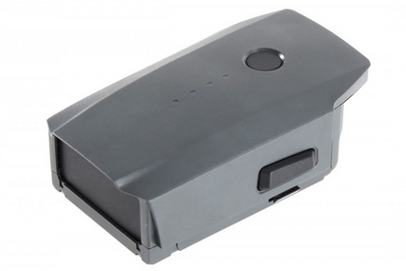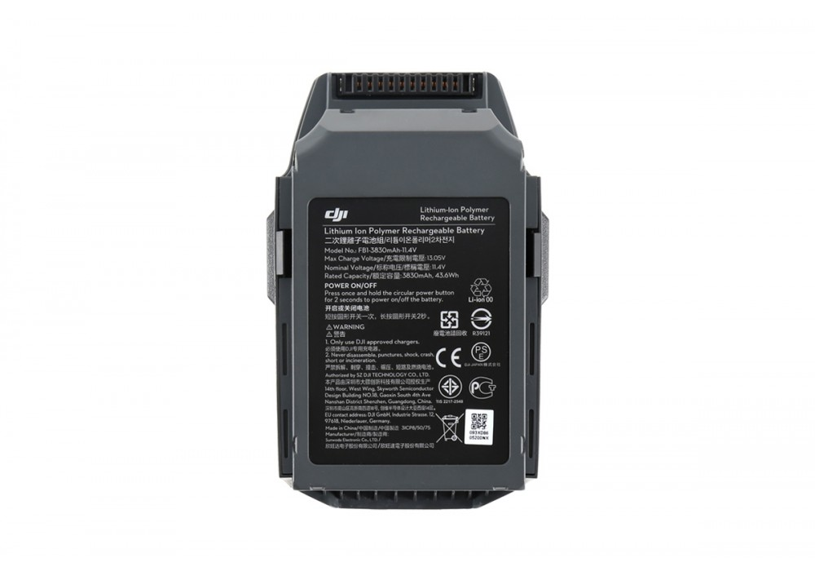  - Kapasitas: 3830 mAh Voltase: 11.4 V  - Tipe baterai: LiPo 3S  - Energi: 43.6 Wh  - Berat bersih: Sekitar 240 gram  - Temperatur operasional: 5 sampai 40 derajat Celcius  - 27 Waktu Terbang  - Integrated Power Management Slot-In Design  - Kompatibel hanya untuk DJI Mavic | 1 Unit
NB:
    - Harga sudah termasuk pajak-pajak

Pejabat Pembuat Komitmen,

TTD

Anton Prasetyo

