
KEMENTERIAN AGAMA
UNIVERSITASISLAMNEGERIMAULANAMALIKIBRAHIMMALANG
FAKULTAS SAINS DAN TEKNOLOGI
JalanGajayana 50Malang 65144Telepon/Faksimil(0341)558933
Website: saintek.uin-malang.ac.idE-mail:saintek@uin-malang.ac.id

Nomor : 2386/FST.1/KS.01.3/08/2019 23 Agustus 2019
Lampiran :1 (satu) bendel
Perihal :Permintaan Informasi Harga Barang

Kepada Yth.
............................................................................................
di
‘- T e m p a t –

Dengan hormat,
Sehubungan rencana realisasi pelaksanaan Pengadaan Modal Peralatan dan Mesin Berupa Peralatan Laboratorium Revitalisasi Laboratorium Jurusan Teknik Arsitektur Fakultas Sains dan Teknologi UIN Maulana Malik Ibrahim Malang, bersama ini kami bermaksud agar perusahaan saudara memberikan informasi tentang harga barang sesuai dengan Rencana Anggaran Biaya (RAB) yang kami lampirkan dalam surat ini.
Informasi harga barang tersebut akan kami jadikandasar survey Harga Perkiraan Sendiri (HPS)
Kami harap data barang dapat kami terima paling lambat pada :
Hari : Rabu
Tanggal : 28 Agustus 2019
Jam : 13.00 WIB
Tempat : Fakultas Sains dan Teknologi Gedung BJ. Habibie Lantai 1
Jl. Gajayana No. 50 Malang (0341) 570886

Adapun informasi harga tersebut bisa dikirim via e-mail ke : saintek@uin-malang.ac.id atau bisa dikirim langsung ke kantor Fakultas Sains dan Teknologi telp (0341) 558933.

Demikian atas perhatian dan kerjasamanya yang baik, kami sampaikan terima kasih.
Pejabat Pembuat Komitmen,

TTD

Anton Prasetyo

Lampiran :Surat Permintaan Informasi Harga Nomor : 2386/FST.1/KS.01.3/08/2019
Tanggal : 23 Agustus 2019

Pekerjaan : Pengadaan Modal Peralatan dan Mesin Berupa Peralatan Laboratorium Revitalisasi Laboratorium Jurusan Teknik Arsitektur Fakultas Sains dan Teknologi UIN Maulana Malik Ibrahim Malang
Lokasi : UIN Maulana MalikI brahim Malang
TahunAnggaran: 2019

No. | Nama Barang  Spesifikasi Barang | Volume | Harga (Rp.) | Jumlah (Rp)
1. | Laser Cutting  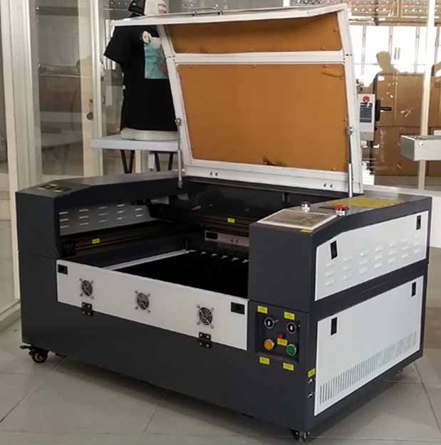  Laser Cutting  Lengkap Dengan training alat dan SOP pengggunaan alat di JurusanTeknikArsitektur Gd. BJ.Habibie Lt. 4.  Spesifikasi Mesin Laser Cutting Engraving JK - 4060:  Model/nama JK : 4060 mesin laser engraving  Ukuran meja kerja : 600*400mm  Laser tabung : CO2  Daya laser : 60 w  Kecepatan potong : 0-3600 mm/s  Kecepatan ukiran : 0-1000 mm/s  Resolusi : 0.01mm/1000 dpi  Dukunganfils : Bmp, HPGL, plt, dstdanaidan lain lain  Perangkat lunak : Corel draw Output langsung/SOFTWARE RD WORK  Tegangan listrik : Ac 110-220 v 10%, 50-60 hz  Lingkungan kerja : 0-45 C 5-95% (kelembaban)  Konsumsi daya : < 300 w  Software yang kompatibel: Coreldraw, autocad, photoshop  Dimensi : 120 (P) x 100(L) x 90(T) | 1 Unit
2 | Thermo hygrometer  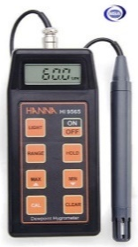  Hanna HI 9565  Range RH 20.0 to 95.0%  Range Temperature 0.0 to 60.0C (32 to 140F)  Range Dew Point -20.0 to 60.0C / -4.0 to 140.0F  Resolution RH 0.1% RH  Resolution Temperature 0.1C / 0.1F  Resolution Dew Point 0.1C / 0.1F  Accuracy RH 3% RH (50 to 85% RH)  4% RH (outside)  Accuracy Temperature 0.5C / 1F  Accuracy Dew Point 0.5C / 1F  Probe HI 70602 RH combined probe with built-in temperature sensor,  microchip and 1 m (3.3') cable (included)  Battery Type / Life 1 x 9V / approx. 250 hours of continuous use;  auto-off after 20 minutes of non-use  Environment 0 to 60C (32 to 140F); RH max 98% non-condensing  Dimensions 164 x 76 x 45 mm (6.5 x 3 x 1.8") | 1 Unit
3 | Wacom Intuos Drawing  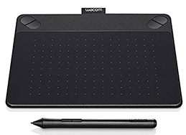  WACOM Intuos Photo PT Small Black CTH-490/K2-CX  Spesifikasi Detail Produk Tablet WACOM Intuos Photo PT Small [CTH-490/K2-CX] | 1 Unit
  Active Area | 152 x 95 mm (6.0 x 3.7 in)
  Multi-Touch | Yes
  ExpressKeys™ | Yes, 4 with application specific settings
  Pressure Levels | 1024
  Wireless Support | Yes (Sold separately)
  Resolution | 2540 lpi
  Reading Speed (Pen) | 133pps
  Pen | Intuos Pen
  Cable Included | Yes
  System Requirements | - USB port  - Internet connection  - CD/DVD-ROM drive  - Windows® 7, 8 or 10  - Mac OS X 10.8.5 or later
  Technology | Patented electromagnetic resonance method
  System Requirements | - USB port, internet connection  - Windows 8, Windows®7 SP1 or Windows® Vista SP2  - Mac OS X 10.6.8 or later (Intel® processor)
  Weight | ±50g
4 | Thermo Anemoneter  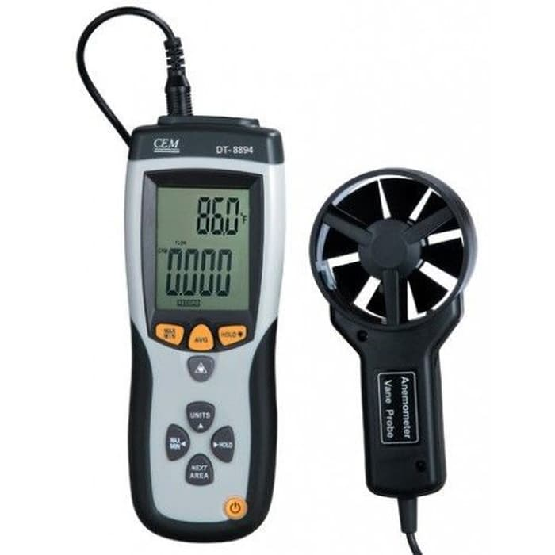  Thermo-Anemometer and Infrared Thermometer CEM DT-889  Simultaneous display of Air Flow or Air Velocity plus Ambient Temperature  Easy to set Area dimensions (cm2) are stored in the meters internal memory for the next power on  Resolution of 0.01m/sec  20 points average for Air Flow  Super large (9999 counts) LCD Backlit Display  3% velocity accuracy via low friction 2.83D (72mm) ball bearing vane wheel on 3.9ft (120cm) cable  Complete with vane sensor with 3.9ft (120cm) cable, 9V battery, and protective rubber holster  MAX/MIN, Data Hold functions | 1 Unit
5 | KYORITSU Digital Light Meter 5202 0.1-19990Lux  Model Number 5202  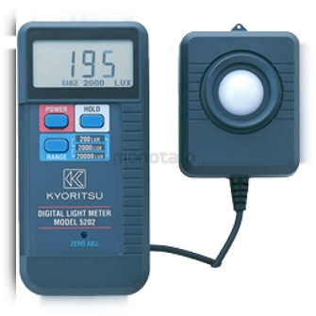  Unit 1unit  Range 0.1 - 19990Lux  Operating Temperature Range 0 - 50 degrees C Below 80% RH  Current Consumption 2 mAh  Response Time 2,5 times/ sec  Power Source 6F22 (9V) x1  Dimension (LxWxD) 148x71x36 mm  Contents Included Carrying Case; 6F22 (9V); Photocell Cover; Instruction Manual | 1 Unit
6 | AC 1.5 PK Sharp AHA12UCY  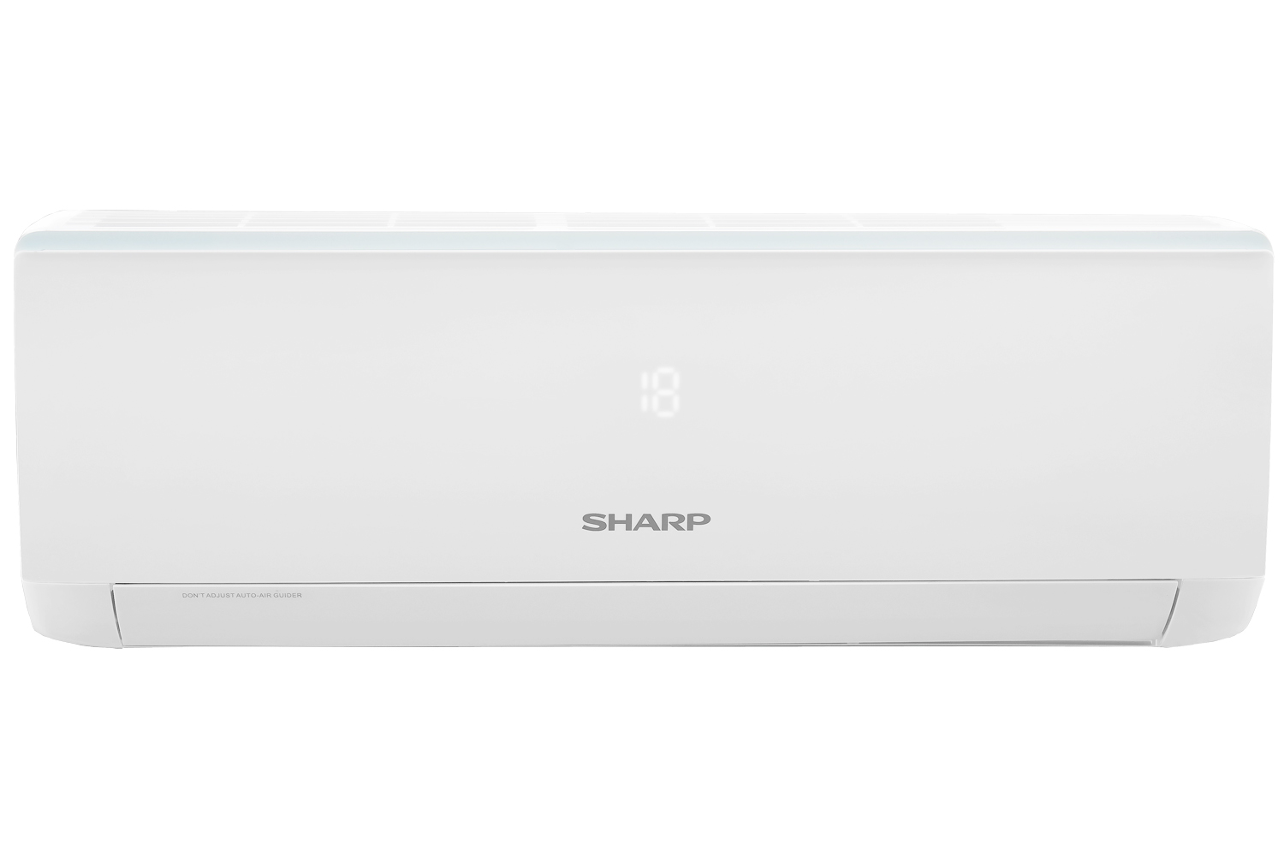  FEATURES  Colour White  Jetstream No  Coanda No  Low Wattage No  Turbo Cooling Yes  Plasmacluster No  Auto Swing Louver 2 - Way Auto Swing  Anti Rust Evaporator No  Self Cleaning Function Yes, X-Fan Function  Remote Control Yes  Coverage Floor Area 16 - 26 m2  CAPACITY  Cool 3.81 kW  Capacity 1.5 PK  Cooling Capacity 13.000 BTU  PIPE DIAMETER  Liquid Side 1/4 inch  Gas Side 1/2 inch  Refrigerant Volume R32  POWER SUPPLY  Rated Frequency 50 Hz  Rated Voltage 220 Volt  Rated Current 7.5 Ampere  Rate Input 1080 Watt  DIMENSIONS  In Door 845 x 289 x 209 mm  Out Door 848 x 540 x 320 mm  NET WEIGHT  In Door 10.5 kg  Out Door 29.5 kg  Harga sudah termasuk pajak  Sudah Termasuk Pemasangan dan kelengkapan ( bracket, pipa AC, pipa pembuangan dan kabel listrik ± 15-20M) | 4 Buah
7 | 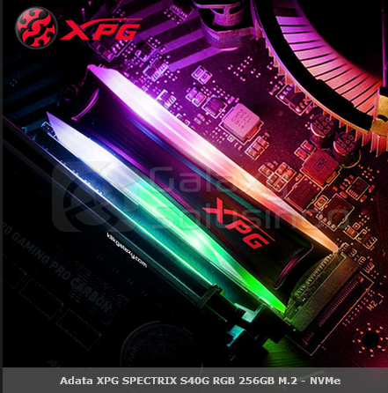  SPECIFICATION:  Capacity 256GB  Form Factor M.2 2280  NAND Flash 3D TLC  Dimensions (L x W x H) 22 x 80 x 8 mm  Weight 13.4g / 0.47oz  Interface PCIe Gen3x4  Performance (Max) read 3500MB/s, write 1200MB/s  Maximum 4K random read / write IOPS : 300K/240K IOPS  * Performance may vary based on SSD capacity, host hardware and software, operating system, and other system variables  Operating temperature 0°C - 70°C  Storage temperature -40°C - 85°C  Shock resistance 1500G/0.5ms  MTBF 2,000,000 hours  Warranty 5-year limited warranty  * The SSD is based on the TBW or Warranty period.  ** Visit www.xpg.com/us/prowar/ for more details.  Note 1. Test system configuration : M/B : ASUS Prime X299-Deluxe II, CPU : Intel®Core™ i9-9820X, CDM ver. : 5.1.2 x 64  2. Performance may vary based on SSD capacity, hardware test platform, test software, operating system and other system variables | 1 Unit
8 | Mavic Pro Intelligent battery  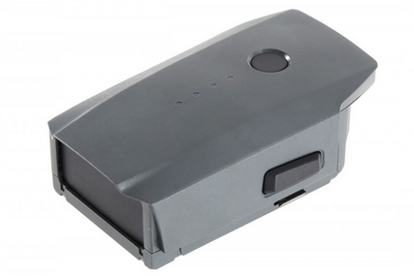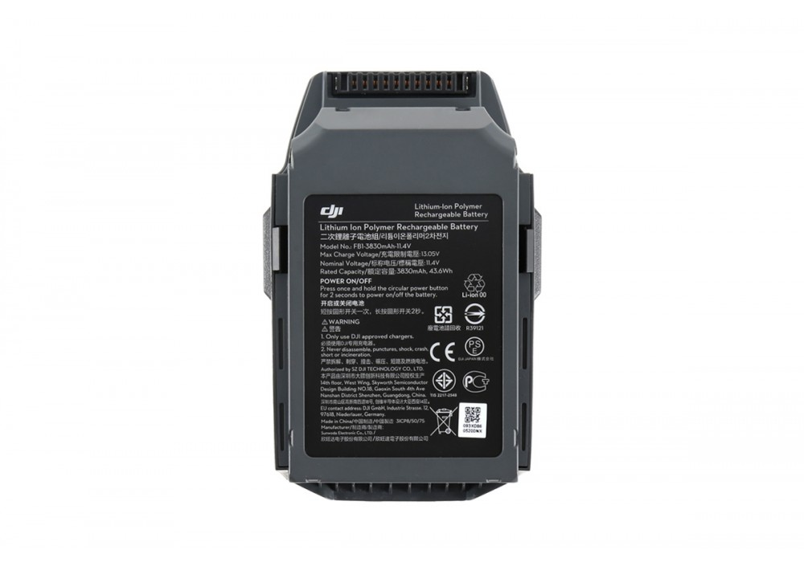  - Kapasitas: 3830 mAhVoltase: 11.4 V  - Tipebaterai: LiPo 3S  - Energi: 43.6 Wh  - Beratbersih: Sekitar 240 gram  - Temperatur operasional: 5 sampai 40 derajat Celcius  - 27 Waktu Terbang  - Integrated Power Management Slot-In Design  - Kompatibel hanya untuk DJI Mavic | 1 Unit
Jumlah
NB:
    - Harga sudah termasuk pajak-pajak

PejabatPembuatKomitmen,

TTD

AntonPrasetyo

